
International Journal of Computer Sciences and Engineering Open Access
Research Paper Vol.-6, Issue-5, May 2018 E-ISSN: 2347-2693

Perception based Framework for Full and Partial Blind Image interpretation using Neural Network

Niveditta Thakur

University Institute of information technology, Himachal Pradesh University-HPU, Shimla, India

*Corresponding Author: niveditta.thakur06@gmail.com
Available online at: www.ijcseonline.org
Accepted: 02/Mar/2018, Published: 31/May/2018

Abstract- With expeditious escalation of digital imaging and communication technologies, inspection of image is a utmost concern. One of the approaches to resolve this issue is to use neural networks. Neural network is fast and powerful scheme with a great ability to deal with noisy or incomplete information. HVS based framework proposed here aims to analyse two kinds of images: First one is fully blind image where there is no reference image available and second is partially blind image where reference image information is partially available as set of certain features. In the first case competitive leaning based self organizing feature map is used to train the network which makes clusters of the input no-reference images. Partially blind image analysis is achieved by training the network using unsupervised feature learning which classifies input in to specific classes on the basis of perceptual features. Many of the Existing methods utilize natural image statistics or probability distribution model which fails to differentiate images in accordance with subjective opinions. This paper considers perceived image features in order to properly classify different images which in turn ease image analysis.

Keywords- Artificial neural network (ANN), Full-Reference (FR), Human visual system (HVS), No-Reference (NR), Reduced-Reference (RR), Receiver operating characteristics (ROC), Self organizing feature map (SOFM).

- Introduction
In recent years computer vision is embellishing throughout areas of science and technology. Computer vision build up intelligent artificial system that finds out necessary information from digital data that comes from real world and in output provides numeric or symbolic information usually termed as decisions. Artificial neural network is one of the ingenious applications of artificial intelligence. Google and Microsoft are using ANN learning which elaborate the manner for computer to do more complex tasks and learn from environment. Major Applications areas include medicine, security, astronomy, microscopy, metallographic, optical character recognition, robotics, defense and remote sensing etc. Parallel processing and infirmity endurance capability of neural network is maximally used to deal with the issues of image processing. Since, machine cannot replace human analyst so there is a need of HVS motivated image analysis tools which is perception based neural network.
Two classification strategies are: Supervised classification and unsupervised classification. Supervised is used in full reference images and reduced reference where original reference image is fully and partially available respectively. Here, human perceptions are imposed on the input data. On the other side, unsupervised is used in no reference images where spectral data or extracted features imposed constraints on human interpretation.
Classification helps in identification of images. Partial blind or reduced reference classifier calculate the numerical properties of various image features and sort out the data into sections on the basis of their content similarity. Whole process consists of feature extraction and then feature classification. Whereas, clustering algorithm automatically segments the training data into prototype classes without analyst’s involvement. Intention here is to cluster a set of no-reference images in several categories and ANN classification of partially blind and noisy images on the feature similarity basis. Thus ANN based classification and clustering generally does the mapping of archive images in to different labels such that set of labels convey the same information as entire image archive. This further ease iamge database handling and also facilitate the operation of efficient image accretion principle and generation of user friendly interface to database. Feature preference and human expectations are playing important role for designing intelligent classification and clustering model.
Organization of the paper is as follows. Section II emphasis the various occurring approaches of generating unknown image class. Section III presents proposed work i.e., neural network inspired classification and clustering of input data. Performance and results analysis is presented in section IV. Finally, conclusion and future perspective is discussed in section V.

- Literature Review
Image analysis has wide application area and for this analysis there is need to increase the awareness of image processing researchers to the impact of the neural network based algorithm which facilitates design of biologically inspired model of quality monitoring. Authors [4] discuss no reference analysis considering large set of features values based on study of comparison of several blind techniques and conclude that include as many features as possible to analyze image. Paper [5] proposes without reference image spatial quality assessor which uses locally normalized intensity coefficients to ascertain destitution of naturalness of distorted image but approach fails to analyze distortion specific features like ringing, blurring block distortions etc. Reduced reference method [6] discussed probability distribution function of wavelet coefficients of archived and distorted image on basis of fact that distortions mainly affect image statistical features. But this method does not work well for geometrical distortions. Havstad et al.[7] used multiplayer perceptron feed forward neural structure, which is practiced to judge the condition of only compressed images based on supervised classification and they find their method superior to MSSIM.
Classification and clustering [8] is done by using a hybrid of SOM and SVM which is application specific considering medical and satellite images and works on small data. Reduced reference degradation dependent image measure proposed in [9] extract features from wavelet based edge map and locate the distortion in image using linear Discriminant analysis. Finally all the features are fused together to form a single measure. Shahid et al. [10] review various no-reference techniques and classify them as pixel oriented methods; bit stream rooted methods, hybrid mechanism; and found that bit stream methods are large content dependent in comparison of pixel based approaches. Paper [11] reviewed so many applications of neural network and found that neural network plays a supporting role rather than a major one. Image understanding is difficult task and promoted the use of ANN’s in three forms: as non-parametric sorters, secondly as non linear regression functions, and third as (un) supervised feature extractor. Feature considered are phase congruency or edges, corner detection (finding out the points of high curvature bending of lines), motion detection, intensity. They figure out that neural network is affected by black box problem: given any input an analogous output is produced, but it cannot be clarified why this judgment has come, and degree of its conscientious.
- Proposed Work
Developing a system for classification of noisy images is a difficult task because of considerable similarities among different classes.
Attributes are first extracted from image and NN is used further to classify them. Features [13-16] considered are structure, contrast, homogeneity, multi scale and multi orientation decomposition, entropy, inertia, gradient and correlation. Features selected must be informative and non redundant, facilitating subsequent learning and generalization steps, leading to better human interpretation. Selected features are expected to contain the relevant information from input data, so that desired task can be performed by using reduced representation instead of complete initial data.
First ANN is used for full reference case where the reference image is fully available as shown in fig. 1. There will be one target image and set of different test images, ANN is trained on the basis of extracted features and recognise desired image from test image set. Reduced reference case in fig. 2 where certain extracted features of original image are known, these known features become target set. Training set is prepared by extracting respective features of all test images. Again feed forward neural network will classify test images on basis of target set.
Test images
Feature Extraction
Classification
Target Image
features

Fig. 1 Full-Reference image classification
Original image
Noise introduction
Feature Extraction
Classification & Interpretation (ANN)
Feature Extraction
RR features

Fig. 2 Reduced Reference image classification
Blind test image set
Feature Extraction
Clustering (SOM) & Interpretation

Fig. 3 No Reference image classification
Neural networks manifest themselves as competitor allocators and non-linear problems like image classification can be inscribed by using these. However, full reference images analysis can be done successfully basis of various existing similarity computational metrics [17] like MSE, PSNR, MSSIM, VIFP, SHSIM, FSIM etc. But for partial and fully blind ANN is utilized since only partial and nil data is there of target image.

A classification problem starts with first preparing data which consists of two matrices input feature matrix Z (column vector of size 37x1) and desired target matrix T. For N test images we have final input matrix Z of size (Z) = [37 N]. Now, if N images come from S classes, then size of matrix size (T) = [S N]. Row containing the “1” is the class index for the corresponding input vector. Input and target matrix for classifying images of fig. 5 is shown in table 1 and table 2 respectively. Classification hopes for the predictions matching with true answers.
Table 1.:
Feature | Image 1 | Image 2 | Image 3
1 | 0.346 | 0.466 | 0.2
2 | 0.000023 | 0.0007 | 0.00009
3 | 0.2 | 0.2 | 0.2
4 | 0.000058 | 0.0003 | 0.0003
5 | 0.00 | 0.000002 | 0.00
6 | 0.00 | 0.000008 | 0.000001
7 | 0.2 | 0.2 | 0.2
- | - | - | -
- | - | - | -
37 | - | - | -

Table 2:
Class | Image1 | Image 2 | Image 3
I | 1 | 0 | 1
II | 0 | 1 | 0
Single layered Feed forward back propagation network with default sigmoid transfer function in the hidden layer is considered. Hidden layer of has default 10 neurons however more perplexing queries can be resolved by using more neurons and perhaps more layers. The network has S output neurons because there are S classes associated with each input vector. Back propagation algorithm is used for learning where input data is applied to the network again and again until error decreases with each iteration and ANN gets proximate to generate desired output.
Above discussed network is utilized for classification of fully (full-reference) and partially (reduced reference) images. No-reference or blind image interpretation is accomplished by competitive learning inspired neural network i.e., Kohonen’s self organizing map (SOM) called clustering. Here average of the squared Euclidean distances between the inputs and their closest prototypes is minimized. SOM understands both the allotment and topology of the feature vectors they are trained on.
- Results And Discussions
Image classification problem is introduced, in which set of test images are considered as shown in fig. 3 taken from TID 2008 database. Since it is clear from the fig. 5, image 1 and image 3 are almost similar falling under same category whereas image 2 is totally different from rest test images which fall under different category. Now Neural Network below fig. 4 is directed to infer these categories for considered test images by following feature learning and finally measures accuracy of predictions. This model achieve 100% classification as we can see in error or confusion matrix fig. 6(a), with zero error and entropy=2.24. But as number of neurons increased say 10 (default value) error is again zero but entropy reduced to 1.96.

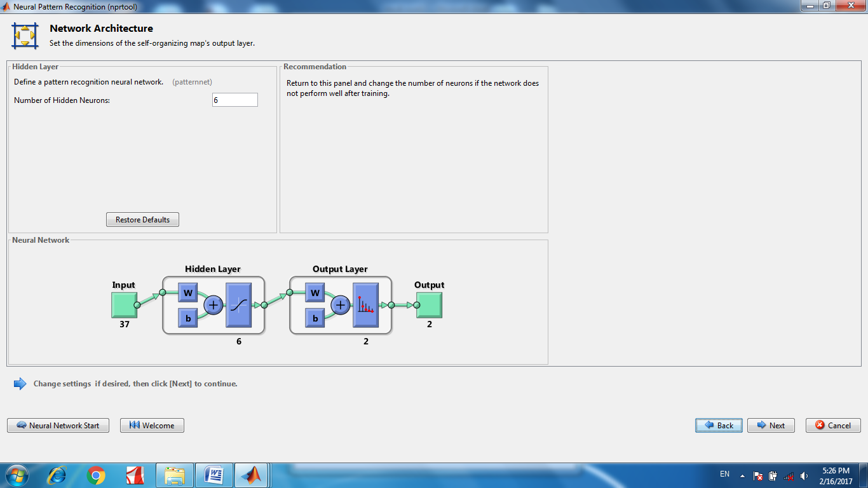
Fig. 4 Neural network model for classification of images fig.5(a~c

(a) (b) (c)
Fig. 5(a) image 1; (b) image 2; (c) image 3; (a) ~ (c) are the test images from TID2008 database to be classified.

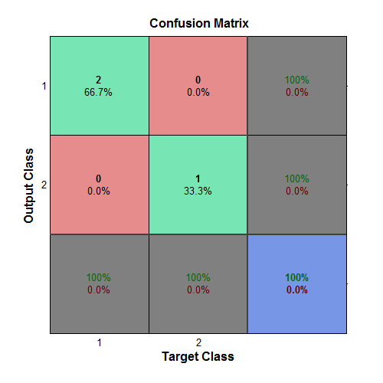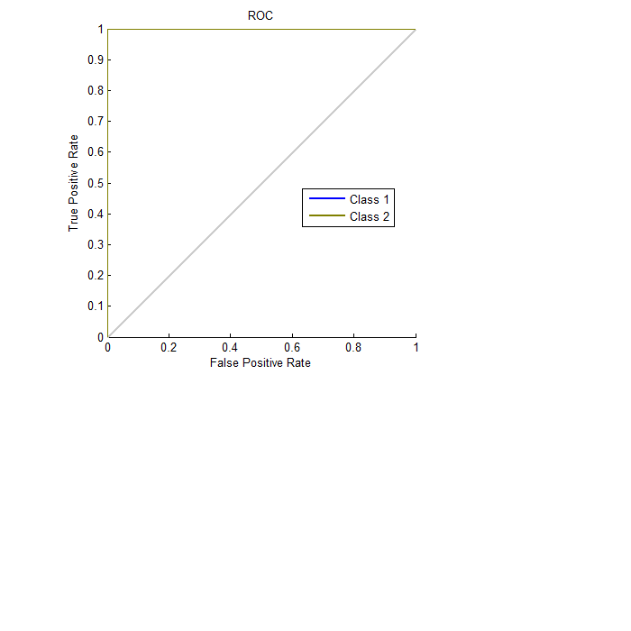
(a) (b)

Fig. 6 (a) Confusion matrix (b) ROC curves; of classified test images of fig.5 (a~c)


(a) (b) (c)
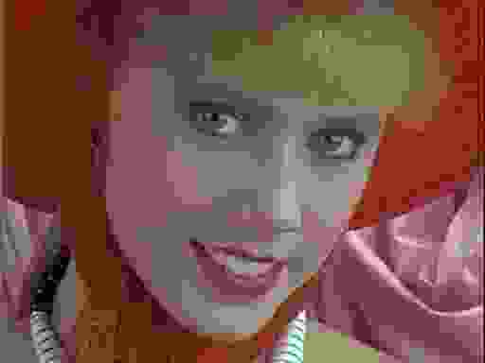
(d) (e) (f)

(g) (h) (i)
Fig. 7 Noisy test images from TID2008 database which are to be classified. Distortion types of (a) ~ (i) are “High blurring”, “JPEG 2000 compression”, “Quantization noise”, “JPEG compression”, “Spatially correlated noise”, “Impulse noise”, “additive Gaussian noise”, “image denoising”, and “Gaussian blur” respectively.

Matrix is 2D layout of actual and predicted values which helps in visualizing performance of classifier. Another parameter is receiver operating characteristics graphs. ROC plots sensitivity along y-axis versus specificity along x-axis. Perfect classification show the points in upper left corner. From fig. 6(b) it is clear that network performs very well.
Now, classification of different noisy images as shown in fig. 7 is done using ANN below:
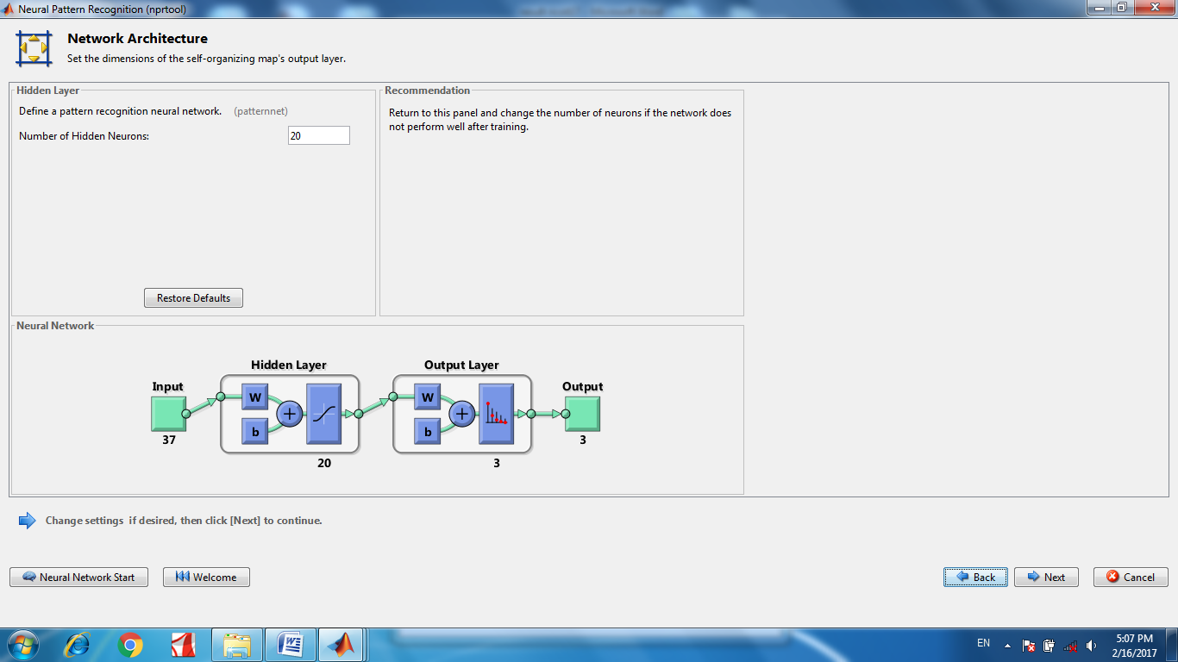
Fig. 8 Neural network model for classification of images fig.7(a~i)

Because of considerable similarities among different classes, ANN based categorization is found difficult with default 10 neurons. Using 10 neurons error is 33% and entropy is 3.34. As, number of neuron increased to 20, in the network shown in fig. 8, 100% classification is achieved with 0% error and entropy 2.42. In this case 7(b), 7(c), and 7(d) falls under one class, 7(a), 7(h), and 7(i) in another class, whereas under last category comes 7(e), 7(f), and 7(g). Confusion matrix and ROC curves of RR noisy images can be seen in fig.9 (a~b). So, with increase in number of neurons complex classification issue can be resolved. However, if number of neurons used are 10, network’s performance can be increased by retraining again. After retraining error is reduced from 33% to 11% and entropy also fall from 3.34 to 2.417.
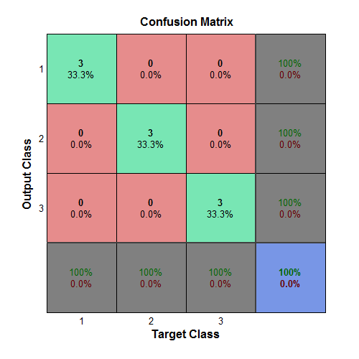
(a)
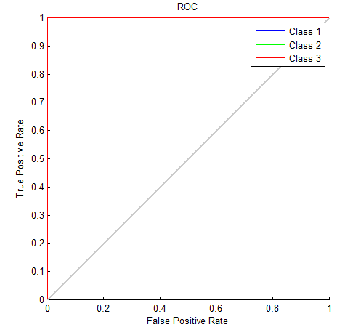
(b)

Fig. 9 (a) Confusion matrix (b) ROC curves; of classified test images of fig.7 (a~i)

Interpretation of no-reference images comes under unsupervised classification or clustering (SOFM network). SOFM is a grid structure or 2D map, in which blue hexagon represents neurons. For fully bind input images fig. 7, network used for clustering is shown in fig. 10 as below:
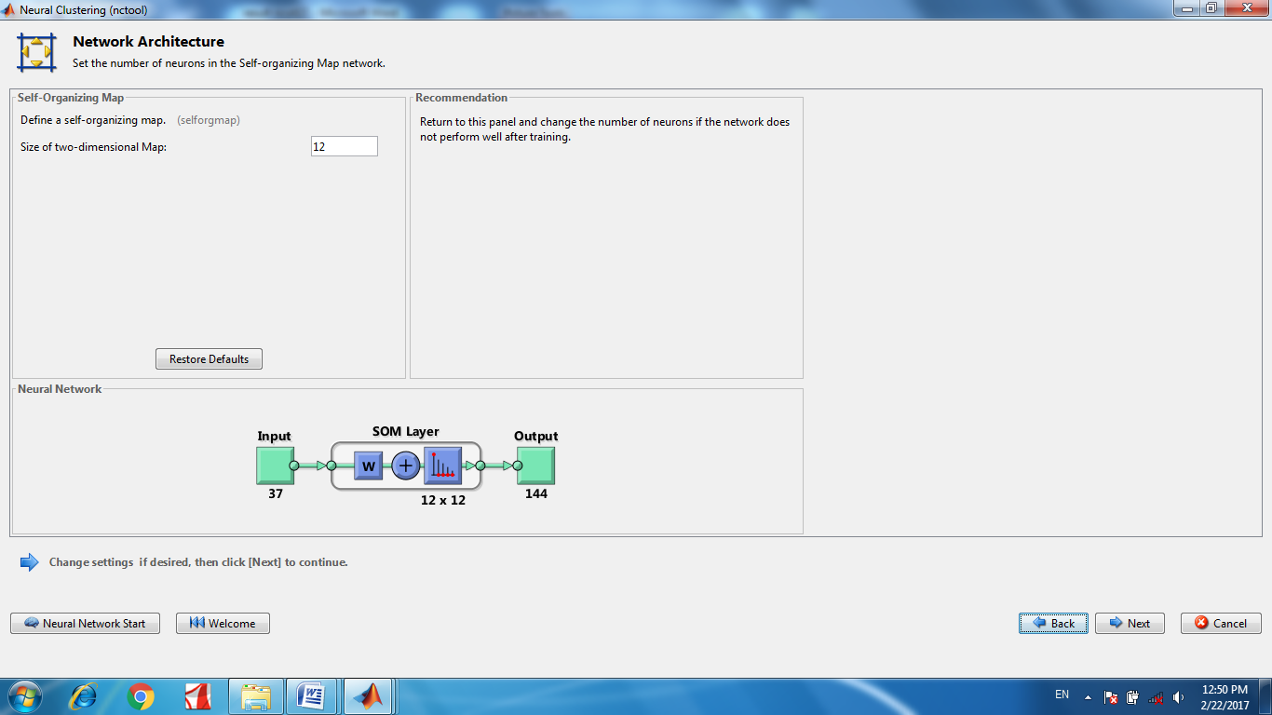
Fig. 10 Neural network model for clustering of images fig.7(a~i)

From the U-matrix or weight distance matrix of the network it appears that SOFM has clustered input NR images in to three groups G₁, G₂ and G₃ can be visualized in fig. 11.
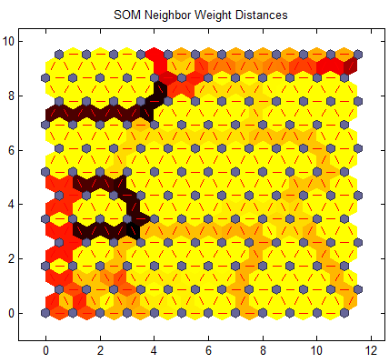
G₁
G₃
G₂
Fig. 11 Plot of SOFM neighbor distances

- Conclusions & Future Scope
Image understanding is an indispensable application of ANNs when images to be classified are closely correlated. Feed forward neural network and SOM architectures are successfully used for supervised classification of partially blind (RR) images and unsupervised classification of complete blind images (NR) respectively. Visual properties of HVS are utilized, by including only human eyes sensitive features which ease in developing successful classification techniques. Regardless of how, computer vision model is unable to reproduce same functionality as of human eye due to abundance of features and hurdles of coping with concomitant variation in position, orientation and scale. Better intelligible, feature selection structure can be developed since prior knowledge i.e., expected image content play a large role here. Also, hybrid fuzzy neural architecture can be utilized for extraction of fuzzy rules after training and may be more applicable in image understanding.

References
[1] | A.C. Bovik, “Perceptual image processing: Seeing the future”, IEEE Transactions on image processing, Vol. 98, No. 11, pp. 1799-1803, Nov. 2010.
[2] | R. David, L. Sovan and L. Jacques,” Artificial neural network as a classification method in the behavioural sciences”, Elsevier Science (0376-6357), pp. 36-43, 1997.
[3] | M. H. Zafar and M. Ilyes,”A clustering based study of classification algorithm”, International Journal of Database Theory and Applications, ISSN: 2005-4270, Vo. 8, No. 1, pp. 11-17, 2015.
[4] | S. Pooja and K.Smriti,” No reference image quality assessment: Feature extraction approach”, International Journal of science and research, ISSN: 2319-7064, Vol. 5, Issue 9, pp. 241-245, Sep, 2016.
[5] | A. Mittal, A. K. Moorthy and A. C. Bovik, “No reference image quality assessment in spatial domain,” IEEE transaction on image processing, vol. 21, No. 12, pp. 4695-4708, Dec. 2012.
[6] | Z. Wang, and E. P. Simoncelli, “Reduced Reference Image quality assessment using a wavelet domain natural image statistics model,” Human vision and electronic imaging, SPIE proceedings,, Vol. 5666, pp. 600-612, Jan. 2005.
[7] | Bouzerdoum. A, Havstad.A and Beghdadi.A,” Image quality assessment using a neural network approach”, Proc. of IEEE Internationl Symposium on signal processing and information technology, pp. 330-333, Dec. 2004.
[8] | P. Shrivastava, P. Singh, G. Shrivastva, “Image classification using SOM and SVM Feature extraction”, International journal of computer science and information technologies, ISSN:0975-9646, Vol. 5, Issue 1, pp.264-271, 2014.
[9] | A. Chetouani, A. Beghdadi, M. Derich and A.Bouzerdoum,”Reduced Reference image quality metric based on feature fusion and neural networks”, European Signal Processing Conference, pp. 589-593,2011.
[10] | S. Muhammad Shahid, R. Andreas, L. Benny and Z. Hans, “No reference image and video quality assessment: a classification and review of recent approaches”, EURASIP Journal on Image and Video Processing, pp. 28-32, 2014.
[11] | M. Egmont Peterson, D. Ridder and H. Handels,”Image processing with neural networks-a review”, Elsevier Science Ltd., pp. 2271-2301, Aug, 2012.
[12] | Zhi-gang Yu, Yong-liang Shen, Shen-min Song, and Da-wei Zhang, “Advances in neural network and applications”, Proc. of International Symposium on Neural Network, pp. 513-520, June 6-9,2010.
[13] | Rafael C. Gonzalez and Richards E. Woods. “Digital Image Processing”, 3rd ed., Pearson Prentice Hall, pp. 675-688, 2016.
[14] | Mark S. Nixon, Alberto S. Aguado, “Feature extraction and image processing,” 2nd ed., Elsevier, Academic Press, pp. 3-14,330-343, 2008.
[15] | Richard O. Duda, Peter E. Hart and David G. Stork, “Pattern. Classification,”2nd ed., Wiley, pp. 15-25, 2007
[16] | Z. Wang and A. C. Bovik, “Mean squared error: love it or leave it? - A new look at signal fidelity measures,” IEEE Signal Processing Magazine, vol. 26, no. 1, pp. 98-117, Jan. 2009.
[17] | A. M. Eskicioglu and P. S. Fisher, “Image quality measures and their performance,” IEEE Trans. Communication, vol. 43, pp. 2959–2965, Dec. 1995

