
International Journal of Computer Sciences and Engineering Open Access
Research Paper Vol.-6, Issue-5, May 2018 E-ISSN: 2347-2693

An automated garden irrigation system: Controlled and monitored via Arduino and Lab-VIEW

M.N. Gogoi

Dept. of ECE, GIMT-Guwahati, Assam Science & Technology University, Guwahati, India

*Corresponding Author: mukti_ete@gimt-guwahati.ac.in
Available online at: www.ijcseonline.org
Accepted: 21/May/2018, Published: 31/May/2018
Abstract— This paper proposed an efficient method of irrigation system for farmer so that they utilized water resource in a proper manner. This method is cost effective, reduced traditional method of irrigation system, low power consumption, and eliminate human intervention. The main aspect of our paper is to determine the soil moisture at some instant of intervals in its dry and wet condition with the aid of soil moisture circuit, evaluate the equivalent moisture and irrigate it based on nature. So the proposed system uses Arduino UNO development board and Lab-VIEW. It is programmed in such way that the sensors that is soil moisture sensor and water level sensor will sense moisture content of the soil and water level of the water storage and fed to Arduino, accordingly it will send command signal to pump to switch ON/OFF based on condition provided by the sensors. For better visualization of the sensors values to farmer, a graphical user interface is developed in LAB-VIEW . The various conditions will be indicated on the front panel such as wet and dry condition of soil with the level of water in the tank.

Keywords— Arduino UNO , LAB-VIEW, LIFA, Soil moisture sensor , Water level sensor

Introduction
Irrigation is the artificial application of water to the land or soil. It is used to assist in the growing of agricultural crops, maintenance of landscapes, and revegetation of disturbed soils in dry areas and during periods of inadequate rainfall.

Irrigation system is now a days become a urgent need of Indian agriculture system. Many of the Indian states within Deccan platue and as well as north India are facing lack of required agricultural water during their important cropping season. Lack of water management system makes the situation worst in most of the cultivating area in semi-arid region of India. Also the absence of technology development such as Supervision of the soil moisture, evaluating its relative humidity and controlling pump motor in accordance with its predictability is very common in Indian Agriculture.
So, it is the need of the hour to examine and controlling the switching action of pumping motor according to the level of water available in the tanks so that proper use of the water is ensured. A water level controller and automatic irrigation controller prevents dry running of pumping motor, thus saves
water, electricity, & also the manpower.

Here, In this paper, the block diagram( fig 1) depicted the automatic water Irrigation system using LAB-VIEW and Arduino Uno interfacing. A soil moisture sensor is a device which monitor moisture level of the Soil and water level circuit sense the water level of the water tank, thus turning pump on and off according to different condition according to soil moisture and different level of water in tank. When the soil humidity is low i.e soil is dry, the water pump is on and if humidity of the soil goes high i.e soil is considered as wet & the water pump goes off. At the same time, the sensor value, used to sense the water level is also considered. When the water level is below the chosen low level, the pump is off at any soil condition preventing the dry running of water pump.

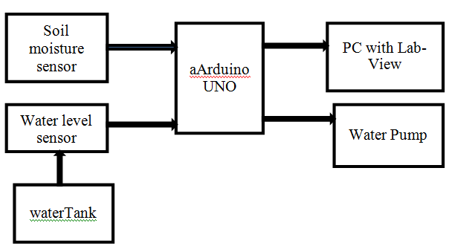

Fig 1: Block diagram

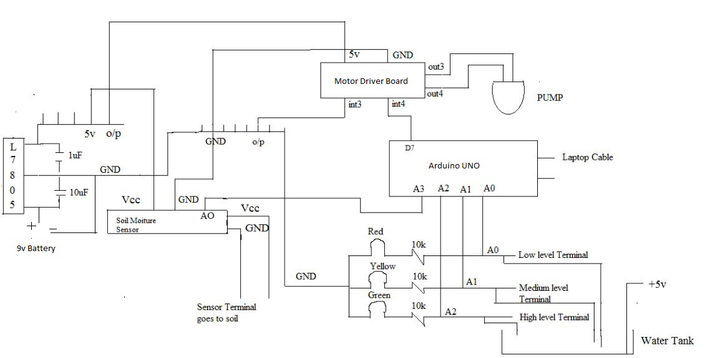

Fig 2: Complete circuit diagram (Hardware)

Arduino UNO is used for interfacing between LAB-VIEW and sensing device. LAB- VIEW is a Laboratory Virtual Instrument Engineering Workbench with a system-design platform and development Environment.

The water level sensor senses the level of water and soil moisture sensor sense the moisture of soil weather it is dry or wet. The reference voltage from both sensors is then fed to arduino board and the control signal will be given to the motor according to the Virtual interface done in LAB-VIEW. Now The signal coming from the arduino is fed to the LAB-VIEW as a input & this signal is compared with minimum or maximum level of the water set and The output of LAB-VIEW is fed to the digital write of Arduino as a input signal. According to digital write output signal, motor in water tank will be turn ON or OFF. The motor turn ON when the water is sufficient i.e water is at low level or above the low level and when soil is dry. The motor will turn OFF when soil is wet and water is sufficient. When the water is insufficient i.e. water level goes below low level either soil is dry or wet,the motor will remain OFF until the sufficient water in the tank.

In this paper, Chapter II contains the procedure of interfacing between Labview and Arduino UNO, Chapter III contains the implementation of software Graphical user interface, Chapter IV represents the complete hardware implementation of the system and at last result and conclusion is discussed in the last chapter.

LABVIEW AND ARDUINO INTERFACING
For interfacing Lab-VIEW and an Arduino, LIFA (Lab-VIEW Interface for Arduino) is used and tested using an Arduino. The LabVIEW Interface for Arduino (LIFA) is a free Toolkit that allows developers to acquire data from the Arduino microcontroller and process it in the LabVIEW Graphical Programming environment. Once the data is acquire in LABVIEW, we can analyze it with the help of built in libraries functions supported by LABVIEW, design the algorithms which will control the arduino hardware and we can display the finding on user interface.

SOFTWARE GUI

Lab-VIEW 2014 software module is used in developing the integrated graphical user interface. various block diagrams which is the sequence of icons that are connected with wires in the manner of flow of operation, is used. the acquired and generated parameters are shown in the front panel. They are in the form of numerical, graphical waveform or as a control. The reqired virtual interface as shown in figure below.

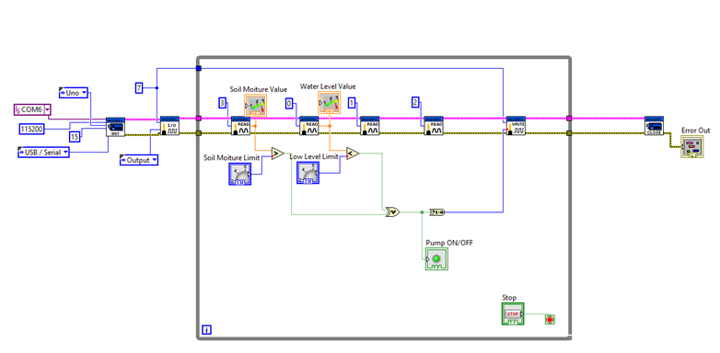

Fig 3 : LabVIEW back panel

For data acquisition from the sensors through the arduino UNO, it is needed to define Initials that includes the type of Arduino board, type of connection (USB/serial), VISA resource/ port selection (COM port), bate rate and at the end define close session and error out. Between these two different others modules are used under the do while loop for the proper flow of the VI design. The Design of the software using LABVIEW is based on the user graphical programming.

HARDWARE IMPLEMENTATION
This part consist of the data collection unit i.e arduino uno development board consist of a microcontroller ATMega 328 with the other circuitries connected which is used as a mean between LAB-VIEW and sensors. Fig 4 shows the complete setup of the hardware system. Here, a wooden box is used to demonstrate the automatic irrigation system. The entire box is divided into four compartments i.e. in the first compartment wet soil is kept, in the second compartment dry soil , in the third a water tank filled up with water and lastly circuit setup is enclosed in the fourth compartment.
The soil humidity sensor, during the damp condition of soils, the two probes behave as electrodes and so the current flows in a closed loop due to the presence of water as a conducting medium of electricity & this is indicated by turning on the yellow LED. When dry soil condition, the loop works as a open circuit and turns on the red LED.
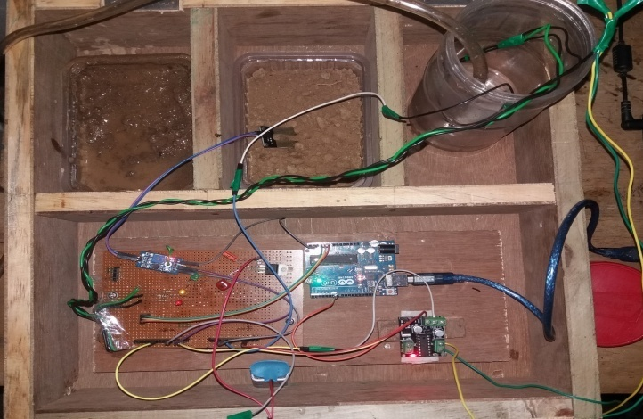
Fig 4 : Hardware implementation

Result

Fig 4 shows the front panel of Lab-View when soil is dry and water is sufficient. Water pump is ON state . The LED glow indicates the pump is ON state [ Here soil moiture unit is set at level 5 and low water indicator level is at 4. Indicator shows that the water level is at 5, so the pump is in ON state].
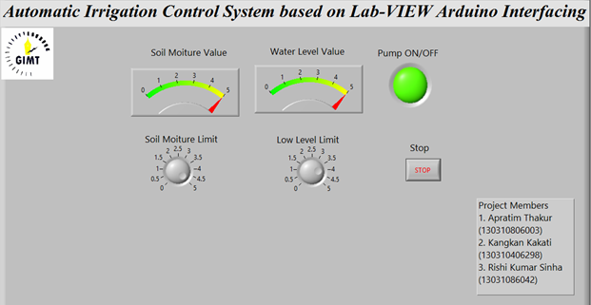

Fig 5 :Lab VIEW Front Panel when the pump is ON

Fig 6 shows the Lab-VIEW Front panel when soil is dry and water isn’t sufficient [below the set stage]. So Water pump is in OFF state. The LED is not glow means the pump is OFF.

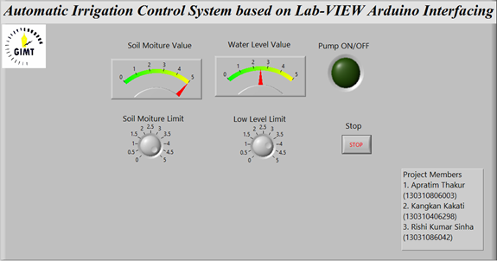

Fig 6 :Lab VIEW Front Panel when the pump is OFF

Fig 7 show the Front panel of Lab-VIEW when soil is wet and water is sufficient. Water pump is in OFF state. The LED isn’t glow means the pump is OFF.

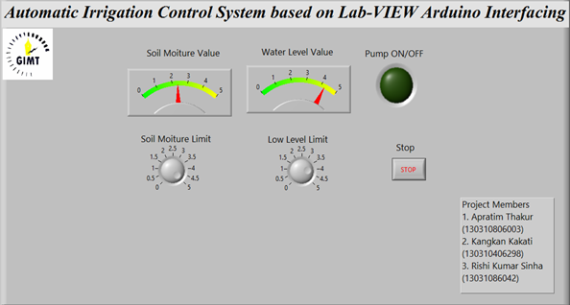

Fig 7: Lab VIEW Front Panel when pump is OFF [wet soil]
Table1: Status of the DC Pump depending upon soil and water sensor
CONDITIONS | SOIL MOISTURE & WATER SENSOR
CONDITIONS | MOITURE LEVEL >=5 | MOITURE LEVEL >= 5 | MOITURE LEVEL < 5
CONDITIONS | WATER LEVEL >4 | WATER LEVEL <4 | WATER LEVEL <4
DC PUMP STATUS | PUMP IS OFF (7) | PUMP  IS ON (8) | PUMP IS OFF (7)

Conclusion
This paper shows how successfully can implemented controlling the motor automatically by using Lab-VIEW and Arduino interface .It provide every- thing that is needed to build any monitor or control application in significantly in less time and in a very cost effective way.
With the use of this technique human can reduced the excessive water consumption in a paddy field. It can be set to lower and upper thresholds to maintain optimum soil moisture saturation and minimize plant wilting. It can contribute to deeper plat root growth, reduced soil runoff/leaching, less favorable conditions for insects and fungal disease. It is also possible to control the nutrition levels in their entirety thus, lower nutrition costs. No nutrition pollution is released into the environment because of the controlled system. Hence it will have great saving of irrigation water, stronger, healthier plants and stable high yields. Hence definitely will have improvement in biological fertility.

References
- T. Bheema lingaiah, D.Hanumesh Kumar, C.Nagaraja, Solomon Woldet- sadik ,“Development of Humidity and Temperature Measurement Instru- mentation System using Lab-VIEW”, International Journal of Advanced Research in Electrical, Electronics and Instrumentation Engineering, Vol. 2, Issue 10, 2013.
- S. V. Devika, Sk. Khamuruddeen, Sk. Khamurunnisa, Jayanth Thota, Khalesha Shaik, “Arduino Based Automatic Plant Watering System”, International Journal of Advanced Research in Computer Science and Software Engineering , Volume 4, Issue 10, pp. 449- 456, 2014
- P. S. Aswale1, Sonal Sali2, Shruti Zarole3, Pranali Patil4, “Automatic Irrigation Control System based on Lab-VIEW Arduino Interfacing”, | IJIRT | Volume 2 Issue 12, 2016
- Sarah Maria Louis, S. Srinithi, 8 “Monitoring of Relative Humidity of Soil Using LabVIEW”, International Journal of Innovative Research & Development, Vol 3 Issue 3, 2014.
- LabVIEW Interface for Arduino [LIFA], decibel.ni.com
- Rekha Sharma, Heena Das, S.N. Das, “WSN for Computerized Irrigation System in Tea Gardens”, International Journal of Scientific Research in Computer Science and Engineering, Vol.4, Issue.2, pp.26-30, 2016.
- Y. Kim, R. G. Evans, W. M. Iversen, "Remote sensing and control of an irrigation system using a distributed wireless sensor network", IEEE Trans. Instrum. Meas, Vol.57, pp. 1379-1387, 2008.
- R. Beckwith. D. Teibel, and P. Bowen Jones, "Report from the Field: Results from an Agricultural Wireless Sensor Network", proceedings of 29th IEEE LCN'04, Tampa, Florida, November 15-17, 2004
- Chandraprakash Patidar, “E-IRRIGATION: An Automation of Irrigation using Wireless Networks”, International Journal of Scientific Research in Network Security and Communication, Vol.1, Issue.5, pp.18-20, 2013.
- Srishti Rawal,” IOT based Smart Irrigation System”, International Journal of Computer Applications, Volume 159 – No, 2017

Authors Profile

Mr. M N Gogoi pursed Bachelor of Engineering from University of Gauhati, Guwahati in 2010 and Master of Technology from Tezpur University in year 2012. He is currently working as Assistant Professor in Department of Electronic and Communication, Girijananda Chowdhury Institute of Management & Technology, Guwahati since 2012. His main research work focuses on Biomedical signal processing, microcontroller and Embedded programming, IoT and archetectural VLSI and DSP processor. He hathan s more 5 years of teaching experience.

