
International Journal of Computer Sciences and Engineering Open Access
Research Paper Vol.-6, Issue-5, May 2018 E-ISSN: 2347-2693

Analysis of Various Image Preprocessing Techniques for Denoising of Flower Images

Isha Patel^{1*}, Sanskruti Patel², Atul Patel³

¹ Faculty of Computer Science and Applications, Charotar University of Science and Technology, Changa, India
²Faculty of Computer Science and Applications, Charotar University of Science and Technology, Changa, India
³Faculty of Computer Science and Applications, Charotar University of Science and Technology, Changa, India

*Corresponding Author: 16drmca001@gmail.com, Tel.: +00-99783-05465

Available online at: www.ijcseonline.org
Accepted: 21/May/2018, Published: 21/May/20182018
Abstract— Identification, and classification of flower images is a crucial issue faced by academicians and researchers. The manual process to distinguish different flower images is a complex task and found difficult for novice persons. A process of extraction, analysis, and understanding of useful information from images is accomplished by an automated process using Computer vision. It basically aims to model, replicate and exceed human vision using computer hardware and software. Image processing techniques may help to recognize a flower image for further identification and classification of them in different species. The fundamental step in image processing is image preprocessing that is applied to improve the quality of images and removing the irrelevant noises existed in images. This paper represents a comparative analysis of different image preprocessing techniques implemented on flower images. The performance evaluation of these techniques is based on their potential to remove noise in flower images. For performance evaluation, Peak Signal to Noise Ratio (PSNR) and Root Mean Square Error (RMSE) methods are used.

Keywords—Image processing, Image preprocessing techniques, PSNR, RMSE

Introduction
In agriculture applications, image processing is having its significant importance. Moreover, one of the growing fields of image processing is floricultural image processing. There are various kinds of flower species available in the world. Each of them has its own characteristics and importance [1]. However, societies who know these flowers are not experts. Therefore, it is very hard for them to recall and differentiate the different flowers. Even an expert who has habituated himself with flowers for a long time sometimes cannot identify the flower correctly [2]. While applying image processing techniques on flower images, the first application is to identify the flower and to classify them an inappropriate way [3]. This classification can be done to identify the individual flower as well as flower category [4] [5]. The common approaches for flower detection comprise with various steps includes preprocessing, segmentation, feature extraction, and classification. Meanwhile, the outcome of each and every phase is the input of next phase, all phases have an essential role [6] [7].
Preprocessing is the essential phase for flower identification and classification. In this paper is divided into three section, section II is about the literature survey, section III is information of image preprocessing and their two phases: image enhancement and image restoration. Each phase includes different techniques elaborated in this paper. And section IV, a proportional analysis is available on various filters applied on flower images.

Related Work
This section covers different image pre-processing techniques used and discussed by various researchers and authors in their papers. KIM (1997) [8] has discussed that the intensity of scene can be altered following the histogram equalization. The essence of the proposed algorithm is to conserve the mean intensity of an image while the contrast is enhanced.
An image enhancement algorithm under non-uniform lighting conditions for digital images is proposed by Saibabu et al. (2006) [9]. The proposed algorithm constitutes three problems, adaptive intensity enhancement, contrast improvement and color restoration. Cheng et al. (2012) [10] has worked upon detection of over- enhancement. The over enhanced areas located accurately and effectively as per shown in an experimental result. To optimize the parameter settings of the contrast improvement algorithms, the given method will be useful.
The contrast enhancement algorithm proposes by Chen et al. (2013) [11] combines two types of methods: histogram equalization based methods (HEBM) and a multi-scales un-sharp masking based methods (UMBM). To attain global contrast enhancement, the algorithm uses HEBM and to attain local multi-scales contrast enhancement, the algorithms use UMBM. Sundaram et al. (2014) [12] proposed technique for Histogram based contrast enhancement for mammogram images that provides better contrast enhancement with preserving the neighborhood information of the mammogram images.
Jaiswal et.al. [13] Worked with denoising of salt–pepper and Gaussian noise. Results of PSNR (peak signal to noise ratio) and MSE (mean square error) are calculated for analysis. Chandrika Saxena et.al [14] has presented a survey on Noises and Image Denoising Techniques. Different types of noises and filters for denoising images are covered in the paper. For an image having salt and pepper noise, the filtering approach has been proved to be the best. Images that are corrupted with Gaussian noise, the wavelet-based approach found the optimum. Meenal et al. [15] survey and analyzed different traditional image denoising method and suggested a new approach which provides a heterogeneous way for the challenging issue. Parmar J.M et. al. [16] proposed an image denoising method using partial differential equation. They proposed three different approaches for blur, noise and blur & noise. This paper discusses different types of noises and result of filters applied to denoise the images.

Image Pre-processing Techniques
Image pre-processing is a fundamental step for noise removal and for enhancing the quality of an original image. The quality of raw flower image can be improved by removing unusual parts from the background of an image. The accuracy of this process can greatly improve by good selection of preprocessing methods. The available techniques considered in this paper for preprocessing stage for flower, which are shown in Fig. 1.
3.1 Image Enhancement
Image Enhancement is a significant process to recover the visual look of an image. It is provided for the “better” transform representation for the next phases of image detection [17] [18]. Image enhancement is characterized in three types:
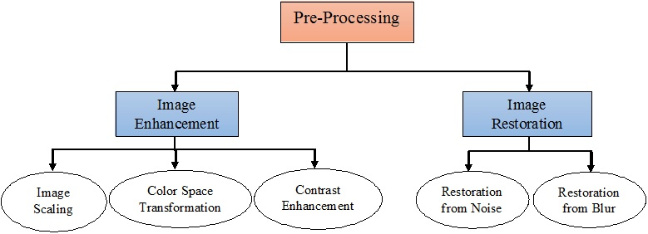
Figure 1. Techniques for preprocessing stage
3.1.1 Image Scaling
Due to the inconsistent size of images, scaling method is applied. Since the flower images are collected from various sources and sizes, so the initial phase is scaling the image and to fix pixel of height and width.
3.1.2 Color Space Transformation
The appropriate data of Color of an image plays an inevitable role in flower identification and classification, it is very much required to appropriate color of flower image for next processing. Commonly, RGB, HSV, HSI, LAB and YCbCr are the common color spaces available for transformation. The best frequent use of colors in image processing is RGB. It has been observed that, RGB color space has some restriction. Therefore, more color spaces have also been established. The purpose of applying Image processing on flower images is to gain the high level intensities to detect the edges of flower petals, it would convert the image into binary and gray-scale [19][20]. The Figure 2 shows the transformed image into gray-scale and binary using Matlab.
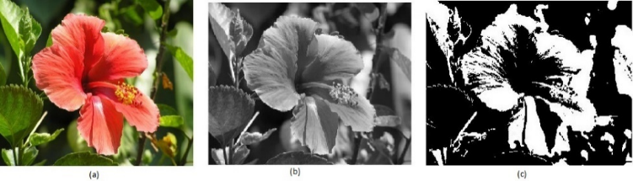
Figure2. (a) RGB image (b) Gray Scale image (c) Binary image
3.1.3 Contrast Enhancement
It is a crucial stage to improve the next processing steps. It can refine the boundary and increase the correctness by highlighting the clarity difference between the foreground and background of an image. In order to increase a quality of an image, it plays an essential role in flower image. The contrast enhancement techniques are further divided into two methods: Linear and Non-Linear contrast enhancement [21]. The following Fig. 3 display the linear contrast enhancement approaches.
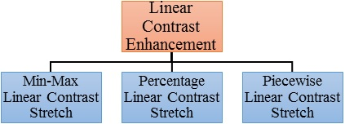
Figure 3. Linear Contrast Enhancement Methods
In Linear contrast enhancement method contrast stretching methods are used. The flower’s image can be converted to higher contrast or stretching the gray-level values therefore the image of histogram is extended over the full range [21]. Fig. 4 shows the resulting images after applying linear techniques on flower image.
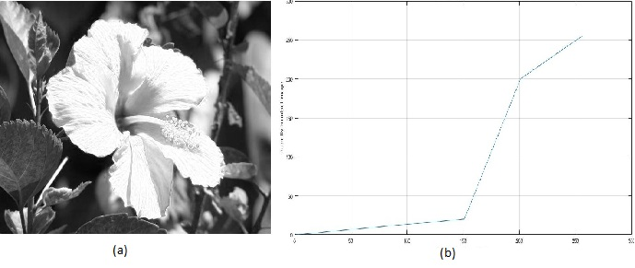
Figure 4. (a) Min-Max Linear Contrast Enhancement (b) Piecewise Linear Contrast Enhancement
On the other side, Non-Linear contrast enhancement method mostly deals with histogram equalizations and algorithms [22]. It avails the various values of outcome image against values of an input image, so, it is losing the brightness of a flower image. Another technique is Non-Linear enhancement illustrated in Fig. 5.
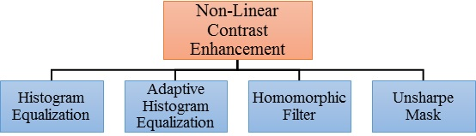
Figure 5. Non-Linear contrast Enhancement Methods
In flower identification using image processing, details of flowers are more important than global, therefore, three familiar enhancement approaches which are more appropriate are Adaptive Histogram Equalization (AHE), Unsharp Masking and Histogram Equalization (HE) [21][22][23][24]. The following Fig. 6 shows the resulting images after applying non-linear techniques on flower image.
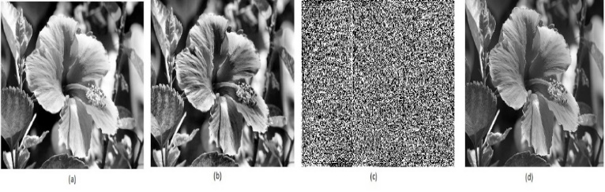
Figure 6. (a) Histogram Equalization (b) Adaptive Histogram Equalization (c) Homomorphic Filter (d) Unsharp Masking
3.2 Image Restoration
It is defined as the process to improve the degraded flower image from a noise and blur [25]. The flower image degradation can occur such as bad focusing, motion, imaging system, etc. [26]. These defects make an image usually blur or noisy [27]. To identify the presented noise in an image is necessary to select the most suitable denoising algorithm.
3.2.1 Image Restoration from Noise
It is a most important phase in preprocessing of a flower image. It is very challenging to apply for various kinds of noisy images. The important property of image denoising technique is to destroy the noise as well as maintaining the edges [28] [29]. The noises can be classified into four types Speckle, Salt and Pepper, Poisson and Gaussian [28] [29] [30] [31] [32].
During image acquisition, sometimes, a noise is added that is denoted as Amplifier noise or Gaussian noise. The example of such noise is a sensor noise occur by low light, high temperature, and transmission noise. Another type of noise is Salt & Pepper noise, often called as Spike noise, and it is always independent and uncorrelated to image pixels. It appears in form of sports, colored as black and white, on the images. Poisson noise corrupts the signal at different proportions and called as Photon noise. The effect of randomly ups and downs in the signal coming back from an object that is denoted by Speckle noise.
The different noises have been simulated in MATLAB 2017 – an image processing toolkit and the resulting images are shown in Fig. 7.
For removal of noise, many methods are available. The main techniques can be categorized into two such as Spatial Filtering and Transform Domain Filtering [36]. There are different filters are available like, Mean, Median, Wiener filter, Total variation filter. The explanation of more common Spatial filters are following [28] [29] [33] [34] [35] [36].

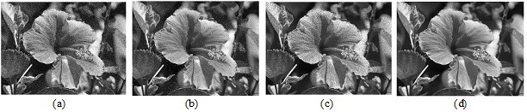
Figure 7. (a) Gaussian noise (b) Salt and Pepper noise (c) Speckle noise (d) Poison noise
• Mean filter: It perform fine with salt and pepper noise and Gaussian noise. While this filter decreases the noise, blur and sharp edges of the flower image. There are various types of mean filters which are describe as follow:
First is Arithmetic mean, it is the simplest of mean filter. It can uniform the noise and well with Gaussian noise. Second is Geometric mean, it can preserve the detail information of an image and enhanced then the arithmetic mean. Third is Harmonic mean, it works well with salt and Gaussian noise, but doesn’t work fine with pepper noise.
• Adaptive filters: It use when the noise is white additive like Speckle and Gaussian noise. It can be divided in to two parts, First is Adaptive local noise reduction filter can be used for random noises. And second is Adaptive median filter which can preserve the details as smoothing non-impulse noise.
• Other filters:
Min and max filters can be used for the finding of darkest points contains by an image. In Median filter evaluation with mean filter is less sensitive to the maximum values. Without reducing the sharpness, it can remove the outlier of an image. It can be useful for salt and pepper noise. Another is Mid-point filter which is the finest for random distributed noises which speckle noise.
The next part of de-noising technique is Transform Domain Filtering, which is depended on wavelet transforms [38]. It is the prolonged form of Fourier transform [37]. Wavelets are well-defined as mathematical functions which analyze data based on resolution. There are various kinds of techniques available in Transform Domain Filtering such as VisuShrink, SureShrink, BayesShrink, Neighshrink, OracleShrink, Smoothshrink and LAWML [37].
3.2.2 Image Restoration from Blur
Blur is a type of image degradation that befalls by bad focusing or motion among camera and original image [39] [40] [42]. Wiener filter, Inverse filter, Neural Network Approach and Lucy-Richardson algorithm are the different techniques for de-blurring of an image [39] [40] [41] [42] [43]. In agriculture applications, Neural Network has been useful as one of the most great and mutual method which also remove the noise [40] [42] [43]. The Wiener filter has been performed in MATLAB 2017 – an image processing toolkit and the outcome is shown in Fig. 8.
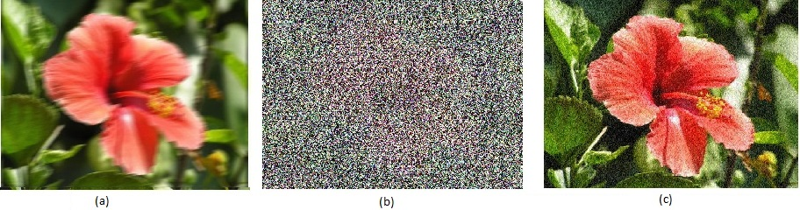
Figure 8. (a) Blur image (b) Restoration of Blurred image (c) Restoration of Blurred using Wiener filter

Results and Discussion
The implementation work is carried out using image processing toolkit - MATLAB R2017a. Performance analysis of four different filters, which process input image with four types of noises, is performed using PSNR and RMSE. These methods are the frequently used methods for performance evaluation of different filters applied on image [44] [45] [46].
There are two error metrics namely Mean Square Error and Peak Signal to Noise Ratio are used to compare image compression quality. The cumulative squared error between the compressed and the original image is represented through MSE. The other is PSNR, represents a measure of the peak error. The lower value of MSE presents the low error. The high value of the PSNR is the better the quality of the reconstructed image. The root-mean-square error is used a measure the differences between values predicted by a model [47] [48].
• MSE (Mean square Error): It is defined as some sort of average or the sum of the square of the error between two images.
Where: (I, J) is the original image, Y (I, J) is the decompressed image, M, N is the dimensions of the image.
• PSNR (Peak Signal to Noise Ratio): It is defined as the ratio between signal variance and reconstruction error variance
Where: MSE - mean squared error, max1 is the maximum possible pixel value of the image.
• RMSE (Root Mean Square Error): It is defined as the square root of MSE.
Where: MSE - Mean square Error
For experimental purpose, the input images are corrupted by simulated Gaussian noise, Salt & Pepper noise, Speckle noise, Poisson noise. For denoising process, average (5x5), median (5x5), min (5x5) and max (5x5) filters have been used. For performance evaluation of above-mentioned filters, we calculate the values of PSNR and RMSE.
Table 1. PSNR
Types of Noise | Noise Variance | Types of Filters
Types of Noise | Noise Variance | Average Filter | Max Filter | Median Filter | Min Filter
Gaussian | 10.592005 | 12.064118 | 11.860393 | 11.773188 | 10.196320
Salt & Pepper | 10.662052 | 11.912949 | 11.729367 | 11.925946 | 10.304306
Poisson | 10.312440 | 12.189660 | 12.162839 | 12.120395 | 11.479873
Speckle | 10.582578 | 12.101204 | 12.172813 | 11.971927 | 11.469388
For the results represented in Table 1, as a parameter for performance evaluation of various denoising techniques, PSNR is used. In PSNR, the highest value is considered as best [47]. The high PSNR value is considered the selection of optimum filter for an image. The image with this value will be considered as an input for image segmentation stage.
Table 2. RMSE
Types of Noise | Noise Variance | Types of Filters
Types of Noise | Noise Variance | Average Filter | Max Filter | Median Filter | Min Filter
Gaussian | 75.325139 | 63.582012 | 65.090940 | 65.747735 | 78.835930
Salt & Pepper | 74.720127 | 64.698282 | 66.080271 | 64.601544 | 77.861882
Poisson | 77.788994 | 62.669640 | 62.863450 | 63.171390 | 68.005891
Speckle | 75.406932 | 63.311116 | 62.791310 | 64.260461 | 68.088035
For the results presented in Table 2, as a parameter for performance evaluation of various denoising techniques, RMSE is used. In RMSE, the lowest value is considered as best [48]. The low RMSE value is considered for the selection of optimum filter for an image. The image with this value will be considered as an input for image segmentation stage.
From the obtained results are shown using Histogram in Figure 9. It shows that the salt and pepper noise affected image is effectively denoised with a median filter so the outcome is low in PSNR and high in RMSE value. But, when compared to other noise like Poisson and speckle produces high PSNR value and low RMSE value. So it is observed that Median filter is not appropriate for Gaussian and salt and pepper noise. But it is appropriate for Poisson and speckle noise.

Figure 9. Histogram of PSNR and RMSE
So, it is clear from the above table 1 and table 2, that PSNR and RMSE values for the proposed approach are analyze the ratio of noise removal filter for the flower images. So, it also shows that which filter is better performed on noise [49]. Image preprocessing allows a various method to be applied on the flower image and can avoid problems such as the collection of noise and blur during processing [50].

Conclusion
This paper discusses the implementation details of different pre-processing techniques required for flower image processing. It has categorized the entire procedure into two divisions of Image Enhancement and Image Restoration. In both these methods, the techniques are used to improve the flower images and the different filters to eliminate the noise, blur and smoothing the images have been described. Moreover, performance evaluation is also discussed using PSNR and RMSE methods. This paper is beneficial for researchers who are working in the area of image processing.

References
- Nisha, Isha, “A Survey on Different Classification Methods on Agricultural Processing”, Journal of Network Communications and Emerging Technologies (JNCET), Volume 3, Issue 1, pp.68-72, July 2015.
- Chomtip Pornpanomchai, Ponrath Sakunreraratsame, Rosita Wongsasirinart, Nuttakan Youngtavichavhart, “Herb Flower Recognition System (HFRS)”, IEEE, Volume 1, pp. V1-123-V1-127, 02 September 2010
- Warisara Pardee, Prawaran Yusungnern, Peeraya Sripian, “Flower Identification System by Image Processing”, Researchgate, August 2015
- Y H Sharath Kumar, N Vinay Kumar, D S Guru, “Delaunay Triangulation on Skeleton of Flowers for Classification”, International Conference on Advanced Computing Technologies and Applications (ICACTA), Volume 45, Issue, C, pp. 226 – 235, 2015
- Fadzilah Siraj, Hawa Mohd Ekhsan, Abdul Nasir Zulkifli, “Flower Image Classification Modeling Using Neural Network”, International Conference on Computer, Control, Informatics and Its Applications, pp. 81-86, 2014.
- Janani, R & Gopal, A. (2013). Identification of selected medicinal plant leaves using image features and ANN. Proceedings of the 2013 International Conference on Advanced Electronic Systems, ICAES 2013. 238-242. 10.1109/ICAES.2013.6659400.
- I.Kiruba Raji, K.K.Thyagharajan, “An Analysis of Segmentation Techniques to Identify Herbal Leaves from Complex Background”, International Conference on Intelligent Computing Communication and Convergence (ICCC), Science Direct, Volume 48, pp. 589-599, 2015.
- Kim, Yeong-Taeg. (1997). Kim, Y.T.: Contrast enhancement using brightness preserving bi-histogram equalization. IEEE Trans. Consum. Electron. 43(1), 1-8. Consumer Electronics, IEEE Transactions on. 43. 1 - 8. 10.1109/30.580378.
- Angela. Saibahu, and K. Vijayan Asari. “An Adaptive and Non-Linear Technique for Enhancement of Extremely High Contrast Images.”, In Applied Imagery and Pattern Recognition Workshop, 35th IEEE, pp. 24-24, 2006.
- Cheng, H. D., and Yingtao Zhang. “Detecting of contrast over-enhancement’, In Image Processing (ICIP), 19th IEEE International Conference on, pp. 961-964, 2012.
- X. Chen and L. Lv, "A Compositive Contrast Enhancement Algorithm of IR Image", International Conference on Information Technology and Applications (ITA), Chengdu, China, IEEE, pp.58-62, 2013.
- Sundaram, M., K. Ramar, N. Arumugam, and G. Prabin. "Histogram-based contrast enhancement for mammogram images.", In Signal Processing, Communication, Computing and Networking Technologies (ICSCCN), 2011 International Conference on, pp. 842-846. IEEE, 2011.
- Ayushi Jaiswal, Jayprakash Upadhyay, Ajay Somkuwar, “Image denoising and quality measurements by using filtering and wavelet-based techniques”, International Journal of Electronics and Communications (AEU), ScienceDirect, Volume 68, Issue 8, pp. 699-705, August 2014.
- Chandrika Saxena, Prof. Deepak Kourav, “Noises and Image Denoising Techniques: A Brief Survey”, International Journal of Emerging Technology and Advanced Engineering, Volume 4, Issue 3, pp.878-885, March 2014.
- Meenal Jain, Sumit Sharma, Ravi Mohan Sairam, “Effect of Blur and Noise on Image Denoising based on PDE”, International Journal of Advanced Computer Research (IJACR), Volume-3, Issue-8, pp. 236-241, March-2013.
- Meenal Jain, Sumit Sharma, Ravi Mohan Sairam, “Result Analysis of Blur and Noise on Image Denoising based on PDE”, International Journal of Advanced Computer Research (IJACR) Volume-2, Issue-7, pp. 70-77, December-2012.
- S.S. Agaian, K.P. Lentz, A.M. Grigoryan,” A New Measure of Image Enhancement”, International Conference on Signal Processing & Communication, pp. 19–22, 2000.
- Dr.K.Thangadurai, K.Padmavathi, “Computer Vision image Enhancement for Plant Leaves Disease Detection”, World Congress on Computing and Communication Technologies, IEEE, pp. 173-175, 2014.
- C.Ananthi, Azha.Periasamy, S.Muruganand, “Pattern Recognition of Medicinal Leaves Using Image Processing Techniques”, Journal of Nano Science and Nanotechnology, Volume 2, Issue 2, pp.214-218, February 2014.
- K. Padmavathi and K. Thangadurai,” Implementation of RGB and Grayscale Images in Plant Leave Disease Detection – Comparative Study”, Indian Journal of Science and Technology, Volume 9(6), pp.1-6, February 2016.
- Mr. Salem Saleh Al-Amri, Dr.N.V.Kalyankar, Dr.S.D.Khamitkar, “Linear and Non-linear Contrast Enhancement Image”, International Journal of Computer Science and Network Security (IJCSNS), Volume 10, No.2, pp. 139-143, February 2010.
- Pooja and Gurwinder Singh Jatana, “Adaptive histogram equalization technique for enhancement of colored image quality”, International Journal of Latest Trends in Engineering and Technology, Volume 8, Issue 2, pp.010-017, March 2017.
- M.Mallika, Dr. J. Jebakumari Beulah Vasanthi, “Image Enhancement Techniques on Plant Leaf and Seed Disease Detection,” International Journal of Innovative Research in Computer and Communication Engineering, Volume 5, Special Issue 1, pp. 109-116, March 2017.
- Deepak J. Dange and Prof. M. A. Sayyad, “Computer Vision Image Enhancement and Plant Leaves Disease Detection”, International Journal of Modern Trends in Engineering and Research (IJMTER), Volume 02, Issue 06, pp. 106-110, June 2015.
- Mohd. Junedul Haque, “A Brief Review of Image Restoration Techniques”, International Journal of Advanced Computing Research, Volume 01, pp. 42-45, 2014.
- Monika Maru, M. C. Parikh, “Image Restoration Techniques: A Survey”, International Journal of Computer Applications, Volume 160, pp. 15-19, February 2017.
- H. Salome Hema Chitra, S. Suguna, and S. Naganandini Sujatha, “A Survey on Image Analysis Techniques in Agricultural Product”, Indian Journal of Science and Technology, Volume 9(12), pp. 1-13, March 2016.
- Gursharan Kaur, Rakesh Kumar, Kamaljeet Kainth, “A Review Paper on Different Noise Types and Digital Image Processing”, International Journal of Advanced Research in Computer Science and Software Engineering (IJARCSSE), Volume 6, Issue 6, pp. 562-565, June 2016.
- Inderpreet Singh, Nirvair Neeru, “Performance Comparison of Various Image Denoising Filters under Spatial Domain”, International Journal of Computer Applications, Volume 96-No.19, pp. 21-30, June 2014.
- Govindaraj.V, Sengottaiyan.G, “Survey of Image Denoising using Different Filters”, International Journal of Science, Engineering and Technology Research (IJSETR), Volume 2, Issue 2, pp. 344-351, February 2013.
- Sandeep Kumar Agarwal and Prateek Kumar, “Denoising of A Mixed Noise Color Image through Special Filter”, International Journal of Signal Processing, Image Processing, and Pattern Recognition, Volume 9, No.1, pp.159-176, 2016.
- Sheikh Tania and Raghad Rowaida, “A Comparative Study of Various Image Filtering Techniques for Removing Various Noisy Pixels in Aerial Image”, International Journal of Signal Processing, Image Processing, and Pattern Recognition, Volume 9, No.3, pp.113-124, 2016.
- Ms. Shweta Gupta, Ms. Meenakshi, “A Review and Comprehensive Comparison of Image Denoising Techniques”, IEEE, page: 972-976, 2014.
- Kumar, Ashok & C. Trivedi, Harsh & Usha Nilkanthan, Mrs. (2015). Development of Salt-and-Pepper Denoising Techniques. 10.1109/ICECCT.2015.7226017.
- Arvind Kumar G., Dr. Ashok Kusagur, “Evaluation of Image Denoising Techniques A Performance Perspective”, International Conference on Signal Processing, Communication, Power and Embedded System (SCOPES), IEEE, pp. 1836-1839, 2016.
- M. C. Motwani, M. C. Gadiya, R. C. Motwani, Jr. Harris,” Survey of Image Denoising Techniques”, Proceedings of GSPX, pp. 27–30, 2004.
- A.K. Kanithi,” Study of Spatial and Transform Domain Filters for Efficient Noise Reduction”, Department of Electronics and Communication Engineering, National Institute of Technology, Rourkela, India, 2011.
- N.Bhoi,” Spatial-Domain and Transform-Domain Digital Image Filters”, Department of Electronics and Communication Engineering National Institute of Technology, Rourkela, India, 2009.
- I. M. El-Henawy, A. E. Amin, Kareem Ahmed, Hadeer Adel, “A Comparative Study On Image Deblurring Techniques”, International Journal of Advances in Computer Science and Technology (IJACST), Volume 3, No.12, pp. 01-08, 22nd December 2014.
- Dejee Singh, Mr. R. K. Sahu, “A Survey on Various Image Deblurring Techniques”, International Journal of Advanced Research in Computer and Communication Engineering, Volume 2, Issue 12, pp. 4736-4739, December 2013.
- Zohair Al-Ameen, Ghazali Sulong, and Md. Gapar Md. Johar, “A Comprehensive Study on Fast image Deblurring Techniques”, International Journal of Advanced Science and Technology, Volume 44, pp. 1-10, July 2012.
- M.Kalpana Devi, R.Ashwini, “An Analysis on Implementation of various Deblurring Techniques in Image Processing”, International Research Journal of Engineering and Technology (IRJET), Volume 03 Issue: 12, pp. 1049-1059, Dec 2016.
- Pooja Dhole and Nitin Chopde, “A Comparative Approach for Analysis of Image Restoration using Image Deblurring Techniques”, International Journal of Current Engineering and Technology, Volume 5, No.2, pp. 1046-1049, April 2015.
- Kamaldeep Joshi, Rajkumar Yadav, “PSNR and MSE Based Investigation of LSB”, International Conference on Computational Techniques in Information and Communication Technologies (ICCTICT), IEEE, pp. 280-285, 2016.
- M. Radhika Mani, V. Lalithya, P.Swetha Rekha, “An Innovative Approach for Pattern Based Image Steganography”, IEEE, presented at the Int Conf Signal Processing, Informatics, Communication, and Energy Systems, pp. 1-4, 2015.
- Kalpana Chaurasia and Mrs. Nidhi Sharma, “Performance Evaluation and Comparison of Different Noise, apply on PNG Image Format used in DE convolution Wiener filter (FFT) Algorithm”, Evolving Trends in Engineering and Technology, Volume 4, pp 8-14, 2015.
- https://in.mathworks.com/help/vision/ref/psnr.html
- https://en.wikipedia.org/wiki/Root-mean-square_deviation
- Anil Kumar Gupta, Dibya Jyoti Bora, Fayaz Ahmad Khan, “Multispectral Satellite Color Image Segmentation Using Fuzzy Based Innovative Approach”, International Journal of Scientific Research in Computer Science, Engineering and Information Technology, Volume 3, Issue1, pp. 968-975, January-February-2018.
- Gagan Madaan, “Various Approaches of Content Based Image Retrieval Process: A Review”, International Journal of Scientific Research in Computer Science, Engineering and Information Technology, Volume 3, Issue 1, pp. 711-716, January-February-2018.

Authors Profile
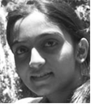
Miss Isha Patel pursed Bachelor of Computer Science from University of VNSGU, Surat, Gujrat in 2013 and Master of Computer Application (MCA) from NIRMA University, Ahmedabad in year 2016. She is currently pursuing Ph.D. and currently working as Research Scholor in Faculty of Computer Science and Applications, Charotar University of Science and Technology, Changa since 2017. Her area of intrest is Image Processing, Machine Learning, and Artificial Intellegence.

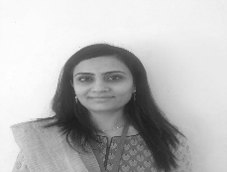
Dr. Sanskruti Patel is currently working as Assistant Professor in Faculty of Computer Science and Applications, Charotar University of Science and Technology, Changa. She is having 12 years of experince inclunding acadamics and research. She has published 20 research papers in various national/international journals. Her area of intrest is Machine Learning and Data Analytics.

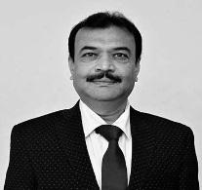
Dr. Atul Patel is currently working as Dean and Professor in Faculty of Computer Science and Applications, Charotar University of Science and Technology, Changa. He is having more than 20 years of experince inclunding acadamics and research. He has published more than 40 research papers in various reputed international journals. His area of intrest is Computer Network, Data Analytics, and Machine Learning.

