
International Journal of Computer Sciences and Engineering Open Access
Research Paper Vol.-6, Issue-5, May 2018 E-ISSN: 2347-2693

Smart Lighting and Interior Blinds Control through IoT
Deepak Makkar^{*1}, Poonam Syal²

¹ Department of Electrical Engineering, National Institute of Technical Teachers Training and Research,
Chandigarh, India
² Department of Electrical Engineering, National Institute of Technical Teachers Training and Research,
Chandigarh, India

*Corresponding Author: makkardeepak25@gmail.com, Tel.: +91-98774-68563
Available online at: www.ijcseonline.org
Accepted: 18/May/2018, Published: 31/May/2018
Abstract— Nowadays, energy usage is increasing due to higher demand than its supply. The electrical energy is mostly utilised in the form of lighting in commercial and residential buildings. The traditional illuminance system uses more electricity than light emitting diode (LED) used in the intelligent lighting system. As the dimming of LEDs can save the extra energy. Therefore, the energy efficient lighting provides better utilisation of the electrical energy. The prime objective of the work presented in this paper is to model intelligent LED lighting system prototype to generate light of the required illuminance level in a room considering energy efficiency and comfort with the integration of daylight. In this system the softwares viz. Proteus and Arduino IDE have been used to evaluate the functioning of the prototype. This lighting system can be monitored online through IoT Platform.

Keywords— Intelligent Lighting System, Online Monitoring, Energy Efficiency, Visual and Thermal Comfort

Introduction
The need for electric energy is increasing over the period of time due to higher comfort level requirement. The increasing demand is the cause of higher load on power utilities. Artificial lighting uses a significant fraction of global electric energy utilization.
In the past, day-lighting was a fundamental component of the design of buildings until the invention of electric light. With the innovation of lighting sources based on electricity, our society began to ignore this free source of energy. The illumination is not adequately planned. Therefore, Even in zones inside the buildings where adequate lighting is accessible from daylight, there is not sufficient lighting in the rooms and the artificial lighting sources are being used at their maximum level throughout the day.
This usage of electrical energy needs to be consumed, particularly in times when the energy crisis is increasing and the ecological concerns is an important issue.
Keeping the present scenario into consideration, there is a need to design energy efficient system which could utilize the daylight to the maximum extent. The objective is to limit the artificial lighting utilization in those areas of the building which get adequate lighting from a natural source of sun during daytime.
The major advantage of using daylight harvesting concept is to decrease the electrical energy utilization. It is well known that energy conserved is energy produced. A unit of energy preserved is equals to 1.25 units of energy produced since a considerable measure of energy is lost in transmission and distribution [1]. Likewise, in India, a developing nation where power is provided to consumers at subsidized rates, the cost of 1 unit of energy spared is equals to saving 6-7 times the cost incurred in producing it [2]. When adequate sunlight is available, a considerable amount of energy can be saved by turning off some of the artificial lights. The control system for LED along with daylight harvesting systems needs to be employed to reduce further energy consumption [3]. The dimming circuit is needed, to enhance the efficiency of the lighting system.
Using the daylight harvesting, the main aim is to utilize maximum available sunlight as the primary source of illuminance as shown in Figure 1[1]. As indicated in this figure, to meet the required level of light, the maximum amount of sunlight is to be utilized with correspondingly lesser amount of artificial light. Daylight Harvesting framework ensures a predetermined light level at the working environment according to different reduced luminance levels from the artificial light when the desired light level is surpassed by the general measure of light (artificial light + sunlight). An illumination control needs to be designed according to the lighting and comfort requirements inside the building, so as to decrease the energy consumption.
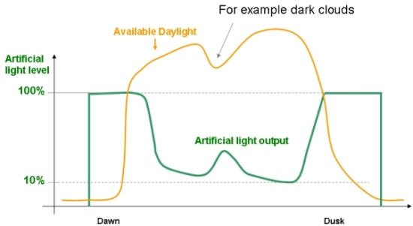
- Line graph showing daylight and corresponding artificial light level [1]
With lighting sources such as LEDs, it is possible to control the light output of the luminaire precisely. The advancements in technology enable control of a lighting system according to the environment [4]. 20% of the electric energy generated is used in illumination [2, 3]. In office and commercial building, in particular, the energy consumed due to lighting sources lies between 20-45% of the overall energy utilization [5].
An attempt has been made by designing lighting system has been designed to develop an Energy Conservation System that will help various organizations to play an effective role in saving electrical energy [6]. In order to preserve energy, automatic lighting system using Raspberry Pi has been developed that monitors the lighting of the room and helps in energy efficiency. The experimental results show that there is a reduction in the amount of electricity bill to the extent of 50% if the lighting luminaires are switched off promptly when not in use [6].
Strategies such as natural ventilation (open/close of windows) & shading are used by occupants to obtain thermal comfort, as it helps in attaining a reduction in time required for mechanical cooling by more than 50% compared with energy based approach [7]. An adaptive thermal comfort approach for buildings which describe the relationship between comfort temperature and outdoor temperature [7].
Thermal comfort is vital for indoor climate control system. With a suitable criteria of comfort conditions, efficient thermal comfort system can be installed to meet the needs of the user. Relative temperature and humidity play an important role in providing thermal comfort system [8].
Indoor thermal comfort is related to indoor temperature and this indoor temperature is directly correlated with the outside temperature of the environment [9]. Blinds are functioned for controlling direct solar radiation entering the room in hot weather as well as blinds also used to for reducing glare and reduction of direct light. The blinds usage increasing with increase in indoor and outdoor temperature [9].
Presently glazed window with blinds is installed in order to achieve low thermal radiation as well as a reduction in indoor temperature and also to provide good thermal comfort [10].
Presently, automated electrical appliances systems are preferred than using manual system. Internet of Things (IoT) is the emerging technique used to make automated electrical appliances system [11]. IoT is playing vital role in automation as it is used for sensing the data from sensors and work according to predefined parameters [12].
A prototype has been developed for the intelligent illumination of the room with has a single window. The intelligent illumination system has been designed to work with the DC power. Two Surface Mount Device (SMD) LEDs have been used as artificial lighting source. The window occupies one wall of the room with the blinds covering this window. The blinds are used to obstructs homogeneous dissemination by the daylight. The control of LEDs in done by acquiring data from light sensors, Light Dependent Resistors (LDR) which is then transferred to Aruino and comparing it with used defined light intensity level. The algorithm developed for intelligent lighting system controls the Pulse Width Modulation (PWM) for dimming of LEDs by taking into account the available indoor light intensity and reference value of indoor light required. The blinds are controlled using outdoor light intensity data and room temperature. As the LEDs operates with DC (Direct Current), so AC grid power is converted to DC using transformer rectifier circuit. The acquired PWM information controls the transistor circuit at the output of the Arduino and by this, the power levels of the LEDs has been adjusted. By adjusting LEDs’ lighting levels, the desired level of the lighting of the environment is attained. In addition, when the occupancy sensor indicates no occupancy in the room, the lighting system will be switched off and blinds will be initially closed.
The following sections discuss the control system developed along with LED illumination system, the smart room lighting system application, Block Diagram and Circuit diagram and the results of the designed and developed intelligent lighting system.

THE LED ILLUMINATING SYSTEM
The hardware platformof intelligent lighting system consists of Arduino Uno, Light Sensor LDR Temperature Sensor, Motion(PIR) Sensor, two Stepper Motors and SMD LEDs Control.
In the lighting system, Arduino Uno R3 microcontroller has been used in the system hardware. Arduino captures signal from LDR light sensors from outdoor light and indoor light sensor. When light falls on this sensor, it provides values of light intensity in the area. DHT 11 temperature sensor senses the indoor temperature of the room and provides temperature values to Arduino Uno R3. The algorithm in Arduino gives the command to the actuators which are steppers motor for movement of blinds and PWM signals to operate SMD LEDs.
Block diagram of the Intelligent lighting system is shown in Figure 2.
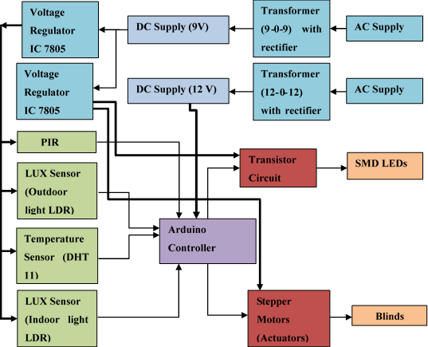
- Intelligent Lighting LED System
The positioning and layout of LEDs, light sensors, temperature sensor, occupancy sensor, in the prototype, is shown in Figure 3.
- The layout of LEDs and sensors in a room
The algorithm generates Pulse Width Modulation data for producing duty cylce which is transmitted into Arduino controller board. Therby lights are dimmed accordingly. The data of the light intensity in terms of voltage is obtained from the circuit of light sensor and potential divider. The Arduino board controls the transistor-based circuit by generation of a PWM signal that switches the transistor at frequency of about 500Hz.

INTELLIGENT LIGHTING SYSTEM APPLICATION
The presented system is designed and configured for energy efficient lighting system application for industrial and commercial purposes.
- In smart room lighting system, the outdoor LDR light sensor senses outdoor light and indoor room temperature for blind movement. The movement of blinds is controlled by stepper motors. The sensing of indoor light is done with the help of indoor LDR light sensor. This sets up PWM signal for light intensity control of LEDs according to the algorithm in Arduino software.
- This whole light sensing data has been provided online with the help of Ethernet shield.
In the control algorithm, shown in figure 4. Based on the data sensor network of light received and temperature of room due to sunlight, it can be adjusted automatically for required illuminance at what PWM rate, LED lamps will work. The block diagram of the algorithm is indicated in figure 4.
- Block Diagram of Control Algorithm

Results
The distributed sensor-based energy efficient Lighting system has been developed and the details are discussed here at different times in a day. Experiments were supervised on this intelligent lighting system to understand performance under different conditions.
The presented system has been designed and configured for energy efficient smart lighting system with thermal comfort for the month of January. The developed system is able to work under different climatic conditions and at different times in a day. The purpose of this model is energy efficiency with daylight harvesting so as to adjust the intensity of artificial lighting automatically according to lux required in a room. The energy consumption with this lighting system is shown in Figure 5.

- Energy consumption for Lighting using Intelligent lighting System.
The bar graph in figure 5. shows the LED power consumption or artificial light consumption in day hours, from morning to evening in the month of January, 2018. This graph is plotted on the basis of PWM of LEDs which is converted into duty ratio using the following formula.
$$\%Consumption=\frac{PWM at Certain Time}{Maximum PWM(255)}*100$$
These results for Day 1 to Day 4 has been noted from prototype of the developed intelligent lighting system. Therefore, the results have been taken by taking the average duty ratio for the whole day that is,
$$AverageDuty ratio =\frac{Morning+Afternoon+Evening}{3}$$
The average efficiency of this system taking into consideration of the month of January is found to be 71.11 %. This indicates that there is a reduction of artificial lighting by 71.11 % of total artificial lighting as compare to conventional lighting system.
Figure 6 shows the energy consumption for energy consumption of lighting for one month, using the Intelligent lighting system.

- Energy Consumption using Lighting System
This lighting system has a feature of sensing lighting data online using Arduino with ethernet shield which will facilitate further studies. This system has been connected with IoT platform as shown in Figure 7.
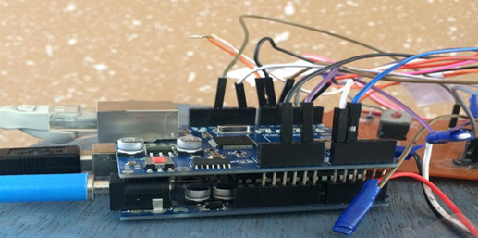
- Arduino with Ethernet Shield for IoT Platform
Using this prototype, different lighting conditions such as sunny, overcast during different times in a day have been displayed online using IoT Platform which is shown in Figure 8. Indoor light intensity is being displayed is shown as LDR LUX 0 and the outdoor light intensity is being displayed as LDR LUX 1. The light monitoring is shown for different conditions of outdoor lighting with artificial lighting. This light sensing data has been provided online with Ethernet shield. The lighting data is being displayed after every single minute
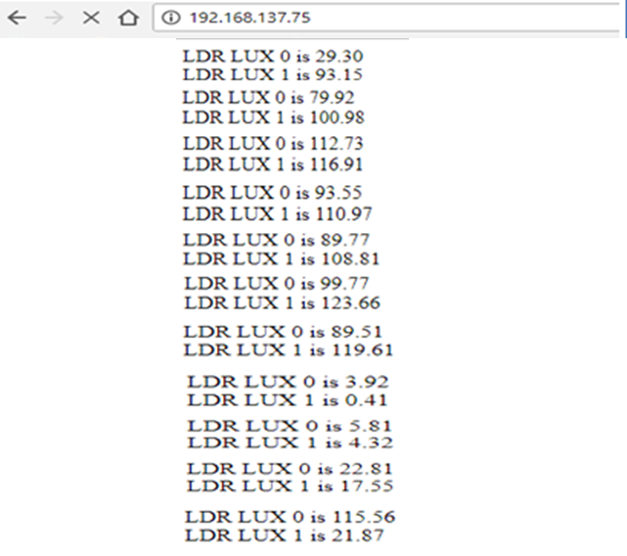
- Display of lighting conditions using IoT Platform

Conclusion AND FUTURE SCOPE
Though the intelligent automation system is being used in industries, houses, institutes, etc., there are still some challenges needed to be overcome for the successful usage of these intelligent systems for control in industries, institutes and research fields.
The aim has been to design an energy efficient lighting system, which can sense indoor and outdoor lights with indoor temperature and occupancy, accordingly to which, the condition required had been implemented. From this study the main conclusions drawn are:
- Based on the real-time information of sensors, the lighting system checks the daylight illuminance. Accordingly, the controller maintains the base level of illumination, by using daylight and switches system off when the room is unoccupied. The controller prevents the daylight glare by automatically adjusting blinds angles. Thus, in daylit buildings, the present scheme optimizes energy conservation and visual comfort as well as thermal comfort. This can also be implemented through online tuning of the controller parameters.
- The developed system is used for higher energy efficiency in a room along with real-time implementation for various conditions of daylight.
Some of the areas for further research have been suggested are as following to continue the project improvement and further research which can be used as an initial orientation for future developers.
- The system developed can be interfaced with MATLAB so that optimised algorithm can be implemented.
- Light sensing needs to be improved with suitable placement of multiple sensors so that better accuracy for implementing intelligent lighting controls for rooms of different dimensions can be achieved.
- Handheld programmer can be developed that can program system instantly for a particular application.
- Developed prototype system can be integrated with solar PV system for making the lighting system environmentally friendly.
The results of the energy efficient lighting system indicates the promising potential of its implementation as well as scope for future research in the areas of conserving.
References
[1] D. Kaur, A. Mukherjee, V. P. Upadhyay, G. Kumar, and S. Raja, "Simulation of Dimmer Circuit for Daylight Harvesting," Energy Procedia, vol. 14, pp. 1075-1081, 2012.
[2] M. A. Özçelik, "The design and implementation of PV-based intelligent distributed sensor LED lighting in daylight exposed room environment," Sustainable Computing: Informatics and Systems, vol. 13, pp. 61-69, 2017.
[3] L. Doulos, A. Tsangrassoulis, and F. Topalis, "Quantifying energy savings in daylight responsive systems: The role of dimming electronic ballasts," Energy and Buildings, vol. 40, no. 1, pp. 36-50, 2008.
[4] A. Pandharipande and D. Caicedo, "Smart indoor lighting systems with luminaire-based sensing: A review of lighting control approaches," Energy and Buildings, vol. 104, pp. 369-377, 2015.
[5] C. de Bakker, M. Aries, H. Kort, and A. Rosemann, "Occupancy-based lighting control in open-plan office spaces: A state-of-the-art review," Building and Environment, vol. 112, pp. 308-321, 2017.
[6] A. M. Aparna K, "Smart Lighting System using Raspberry PI," International Journal of Innovative Research in Science, Engineering and Technology, vol. 04, no. 07, pp. 5113-5121, 2015.
[7] A. P. A. Page, P. Ferrão, J. Fournier, B. Lacarrière, and O. Le Corre, "Thermal Assessment of Buildings on Occupants Behavior and the Adaptive Thermal Comfort Approach and the Adaptive Thermal Comfort Approach " Energy Procedia, vol. 115, pp. 265-271, 2017.
[8] S. C. Turner, ASHRAE STANDARD (Thermal Environmental Conditions for Human Occupancy). 2010.
[9] J. F. N. Iftikhar A. Raja, Kathryn J. McCartney, Michael A. Humphreys, "Thermal comfort: use of controls in naturally ventilated buildings," Energy and Buildings, vol. 33, no. 2001, pp. 235-244, 2001.
[10] Y. Zhang, L. Huang, and Y. Zhou, "Analysis of Indoor Thermal Comfort of Test Model Building Installing Double-Glazed Window with Curtains Based on CFD," Procedia Engineering, vol. 121, pp. 1990-1997, 2015.
[11] A.Pandey, A.Gautam, M.tiwari, "IOT Based Home Automation Using Arduino and ESP8266," International Journal of Computer Sciences and Engineering, vol. 6, no. 4, pp. 267-271, 2018.
[12] A. K. Kratika Gupta, Suraj Rasal, Varsha S. Rasal, "Importance of Sensor Readings and Its Secured Delivery in Internet of Things," International Journal of Computer Sciences and Engineering, vol. 6, no. 1, pp. 320-325, 2018.

Authors Profile

Mr. Deepak Makkar pursued Bachelor of Technology from Global College of Technology, Jaipur in 2014. He is currently pursuing Master of Engineering from National institute of technical Teachers Training and Research, Panjab University, Chandigarh in year 2018. His main research work focuses on energy Efficiency Based systems, Renewable Energy based Technologies, automations, Controllers.


Dr. Poonam Syal pursued her Ph.D.(Engg. &Tech.) from Panjab University, M.Tech.(Electrical Engineering), B.Tech.(Electrical Engineering) from Punjab Engineering College, Chandigarh. She works as Associate Professor at National Institute of Technical Teachers Training and Research, Chandigarh. She has published and presented more than 25 Research papers in international journals and conferences. She has one patent pending related to assistive technology for visually challenged Her main research work focuses on energy Management, Renewable Energy based Technologies, Assistive Technologies, Appropriate Technology, Manpower Development and Skill Training.

