International Journal of Computer Sciences and Engineering Open Access
Review Paper Vol.-6, Issue-5, May 2018 E-ISSN: 2347-2693

3P Invovlement in Software Requirement Engineering Process

Akshara B. Dave^{1*}, S.M. Shah²

¹ MCA Dept, CMPICA, CharuSAT, Aanad, India
² Narsinhbhai Institute of Computer Studies & Management, Kadi, India

*Corresponding Author: Akshara.dave@gmail.com, Tel.: +91-98791-08751

Available online at: www.ijcseonline.org
Accepted: 24/May/2018, Published: 31/May/2018
Abstract— This paper focuses on software project management’s one of the important issues- 3P. 3P involves “People”, “Process” and “Product”. These are the key factors any project may have involved. Also it discusses various issues encountered while a project is being developed. Issues may be technical or personal. Main aim of this research paper is to focus on various aspects of software development and impact while key factors involved. The paper describes Software Requirement Engineering process in short and 3P involvement in them. People from various levels and of various levels participating to develop a product are often tend to succeed if followed a particular functioning. Concepts of 3P are discussed in terms of requirement engineering are explained in this research paper.

Keywords—Project management, software requirement engineering, Software Development, Client’s invovlement, Software Processing, Project planning.

Introduction
Software Project planning is such a big thing that none of the industry have announced they haven’t faced any difficulty while planning or actually implying their own project planning. In this global scenario, various IT industries have plenty of working style approach to take up. In that case, comparing work of some industries with other ones are not worth. All work depends upon PROCESSIING WITH PEOPLE FOR PEOPLE TO GET A PRODUCT. As 3P is a famous concept of software engineering, it is necessary to discuss how it is implemented at various levels in detail. As requirement elicitation is the first phase, it is necessary that requirement gathering to be performed in careful environment.
The paper is organized as follows, Section I contains the introduction of software requirement engineering and its involvement in IT industry, Section II covers a proposed framework for requirement engineering process and its description, Section III contains all information related to the main topic of this research paper. Section IV is the conclusion of whole research paper.

Software Requirement engineering process
Information technology field is no longer bound to single technology or working formats, people working at various stages in IT industry are keen to welcome new technologies and finding new ways. In that case, a software is not been software only, it is available as applications on mobile, a website, a web browser or various technical devices which makes normal people’s life easier. Hence, technology is meant for people only. Software Engineering involves every aspect regarding software application, methodology involved in it, its development and its functions. Requirement elicitation is one of the important parts of software engineering. Requirement engineering is process of collaborating and consolidating of what the services should be provided by the system.

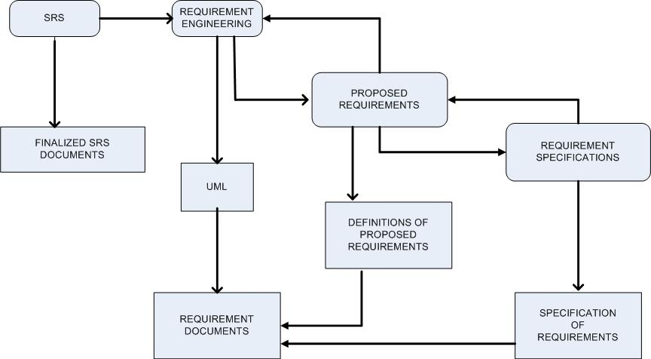
- Framework for requirement engineering process
Once, Development team gets documented requirement (Generally termed as SRS (Software Requirement Specification), after then, requirement elicitation process is put on SRS and improtant requirements are formed togather. If there are updation in formed requirements, then it is reffered again and updation made. On the basis of requirement elicitation process, UML is formed to differentiate entities and tasks assined to them. After final updation, suitable requirement specifications are derived. Based on this, most suitable requirement specification are noted having customer’s involvement. Once, requirement specifications are clear and UML is also formed, a document is created which is a final document reffering to important requirements given by customers and to be processed further. This figure is a proposed framework for requirement engineering process. As noted earlier, it is upto various IT industry and its team members if they find it suitable or not. As AGILE is in trend now a days, it is best to work with.

concept of 3p
Given 3P:
- People
- Process
- Product
Managing these 3P first in project management is the key of success. They are interconnected with each other. For example, people: people can be an end-user, a developer from development team or a project manager. Without anyone of them, building a proper project is impossible. With the capability of people product is built. But without following a proper process flow, it is impossible. Hence, process is important as well to build a product. Finally, a product is something for which whole representation has taken place.

- People
There are people involved when talk about software requirement elicitation. Technically, while preparing use cases, they are known as entity. In general terms of project management, they are known as “players”. They are project managers, end-users, customers, development team members and other people directly or indirectly involved in that project. Here there is difference between end-user and customer:
Customers are the one who:
- Originally requested to build software, communicate with development team.
- Defines overall business and product objectives.
- Provides basic product requirements.
- Co-ordinates funding for product.
End-users are the one who:
- Actual people who are going to use the product.
- They will define operational details of software, so business purpose will be achieved.

In many cases, end-users/ customers have the clear idea about what they want as a final product. So, they give brief idea about their “do and don’t”. While following AGILE methodology, customers are present at time of regular mock-ups. By doing this, they can get the actual idea about their product. So, they can link requirement presented for their need and output at every scrum. With this, requirements are set more clearly to them and imagination of how product will work gets more transparent.

It is the main duty of development team to apply their technical skills and built up the product. It is a product for client and project for team members. Sometimes senior members from company would like to join as a team member for a particular project. However they show their interest in project and aim to know their customers. With that, they can also get to know the most interested and influence person from development team for their growth in company. Some of project managers also have admitted they like to work with young generation to stay in touch with them as they have deep technical knowledge and strong attitude to deal with customers [3]. Sometimes, HR team also pushes senior managers to seat back and notice work of their own team members to know them personally.
It is beneficial for team members only if they involve their customers in requirement elicitation. So that, they can focus on primary requirements, functional and non functional requirements and specification of requirement gets clearer.

- Process
Till now, there is no process has been discovered which says “100% effective anywhere, anytime”. Process varies from project to project, from team to team and even firm to firm.
Process involves - defining, to develop, to deliver and to support. It takes time to figure out how to begin and draw management aspects of a project. On this point, selection of proper process model works best. Selection of process model is done by project manager. This model can be universal accepted model or project team can also make its own process flow model according to project. The biggest challenge they face is to merge product with process. Process must be made to complete product. To ease this work, some set of attributes are given: communicating, Planning, Developing, testing, delivering and customer feedback

- Product
Product aka project involves lot of things. Main of them are defining project objective, scope and execution planning.
Main aim of team is to develop product and to deliver it on time. To make the product delivered here are some points to ponder:
- Project scope identifies in-house needs of project
- Clears objectives and works accordingly
- Smartly cut off not required things from project
- Works according to timeline and delivers
Development of product might take number of days or number of months as well. To deliver it on time, time line chart is generated and is strictly followed.
A product is feasible or not is answered from final requirement document. Hence, it works well on software requirement engineering process model on creating requirement documents. Customers can easily imagine their product being built scrum to scrum or module to module.

Conclusion and Future Scope
As this paper cites connection of 3P with requirement engineering, it provides information driven data. 3P has been tested in many environments in terms of project management but if emphasised more on the first step of any development related issues in software engineering, it will be more beneficial for IT firm and related people only.

Acknowledgment
For creating this research paper, author would like to thank her guide Dr. S. M. Shah who is also a co-author of this research paper. Author is also thankful to all the professors who helped and motivated her at different career paths.

References
- Kuloor, c., and Eberlian, A., “Requirement engineering for software products”, The University of Calgary, Canada, pp 1-12.
- The Standish Group. The CHAOS Report. Denish, MA: The Standish Group, 1994.
- Pfleggeer S. L., “Software engineering Theory and practices”, Prentice Hall, New Jersey, 1998.
- Reifer D. J., “Requirement Management: The search for Nirvana”, in IEEE software, May/June 2000, pp 45-47
- U. K. Jannat , “Green Software Engineering Adaption In Requirement Elicitation Process,” INTERNATIONAL JOURNAL OF SCIENTIFIC & TECHNOLOGY RESEARCH, vol. 5, no. 8, pp. 94–98, 2016.

Authors Profile
Akshara Dave received the B.Sc.(I.T). and M.Sc.(I.T) degrees from J.P. Dawer Institute of Information Technology in 2007 and 2009, respectively. During 2009-2013, she served as Assistant Professor at various colleges in Gujarat, India. She taught in BCA(Bachelors in Computer Application), MCA(Masters in Computer Application) and M.Sc.(I.T)- Masters of Science in Information and Technology. at every iteration, requirements get clearer, more separable and more convenient to understand. The result we get is a short yet detailed requirement document.

Dr. Sanjay M. Shah is currently working as a director in Kadi Sarva Vishwavidhyalaya in Masters of Computer Application Department. His main research area is mathematics with Computer Application. He has 30 years of teaching experience and 11 years of research experience.

