
International Journal of Computer Sciences and Engineering Open Access
Research Paper Vol.-6, Issue-5, May 2018 E-ISSN: 2347-2693

Face Recognition based smart attendance system using IOT
Sakshi Patel^{1*}, Prateek Kumar², Shelesh Garg³, Ravi Kumar⁴
¹Department of ECE, Jaypee University of Engineering and Technology, Madhya Pradesh, India
²Department of ECE, Jaypee University of Engineering and Technology, Madhya Pradesh, India
³Department of ECE, Jaypee University of Engineering and Technology, Madhya Pradesh, India
⁴Department of ECE, Jaypee University of Engineering and Technology, Madhya Pradesh, India

*Corresponding Author: thesakshipatel@gmail.com, Tel: 8889654455
Available online at: www.ijcseonline.org
Accepted: 16/May/2018, Published: 31/May/2018
Abstract- Attendance is a compulsory requirement of every organization. Maintaining attendance register daily is a difficult and time consuming task. There are many automated methods for the same available like Biometric, RFID, eye detection, voice recognition, and many more. This paper provides an efficient and smart method for marking attendance. As it is known that primary identification for any human is its face, face recognition provides an accurate system which overcomes the ambiguities like fake attendance, high cost, and time consumption. This system uses face recognizer library for facial recognition and storing attendance. The absentee’s supervisor or parents are informed through email regarding the absence of their employees or wards respectively. The objective of this project is to innovate existing projects with some added feature like large data storage and fast computing through less hardware cost.
Index term –Smart attendance system, Raspberry pi3, OpenCV, Face_Recognition, SMTP

I. INTRODUCTION
Every organization requires an attendance system to maintain record of presence of student and employees. They have their own method to do the same. Some do manually and some use automated attendance system. Manual method includes pen and papers which consumes lot of time and wastage of resources. Also, it has risk of proxies and human error. Automated attendance system includes many methods like -
I.I RFID – Radio Frequency Identification is one method for attendance making. In this technology an individual has to carry his own RFID card. Therefore, this system is cost effective and can also give rise to fraud as any unauthorized person can use the card for fake attendance.
I.II Biometric – This system includes fingerprint, iris and voice recognition. Biometric authentication systems are not 100% accurate. False rejection and false acceptance are some errors that can give rise to fraud.
I.III Face Recognition – is one of the most efficient systems of all existing ones for identification of people. It can be used in school, colleges or any organization. To avoid the difficulty of taking attendance of large number, there is a need of automated attendance system that is fast and reduces the chance of fake attendance. In this technology system is developed for deploying an easy and a secure way of taking down attendance. This attendance is recorded, by continuously detecting faces of employees or students via camera as they enter the classroom. The software first detects the faces and simultaneously compares them with the predefined database.
Section II describes the existing techniques in this field. Section III of the paper describes the proposed method for face recognition and generation of attendance report. Section IV gives an idea for hardware used in the proposed work. Result is shown in Section V. Conclusion is deliberated in Section VI.
II. EXISTING TECHNIQUES
Charles Walton is best known as the first patent holder for the RFID (radio frequency identification) device. He also received a patent for a passive transponder used to unlock a door without a key. A card with an embedded transponder communicated a signal to a reader near the door. When the reader detected avalid identity number stored within the RFID tag, the reader unlocked the door. [1]
Michael Dobson, Douglas Ahlers, Bernie DiDario, in 2006 gave a concept of Attendance tracking system. The system includes identification tags, with wireless communication capabilities, for each potential attendee, scanners for detecting the attendees' tags as they enter a given room. [2]
O. Shoewu and O.A. Idowu: Development of Attendance Management System using Biometrics. Attendance is taken electronically with the help of a finger print device and the records of attendance are stored in a database. Attendance is marked after student identification. [3]

The idea of using principal components to represent human faces was developed by Sirovich and Kirby 1987[4] and used by Turk and Pentland 1991[5] for face detection and recognition. It tracks a person’s face and then recognizes by comparing characteristics of the face to those of known individuals. Initially, a principle component factor “eigenvector” is determined using PCA then the set of characteristic feature image "eigenface" are found.

Paul Viola and Michael Jones in their 2003 article titled, “Robust Real-Time Face Detection”: It describes a machine learning approach for visual object detection which is capable of processing images extremely rapidly and achieving high detection rates. It brings together new algorithms and insights to construct a framework for robust and extremely rapid object detection. The simple features used are reminiscent of Haar basis functions which have been used by Papageorgiou et al.
Haar-like features are digital image features used in object recognition. In the detection phase of the Viola–Jones object detection framework, a window of the target size is moved over the input image, and for each subsection of the image the Haar-like feature is calculated. This difference is then compared to a learned threshold that separates non-objects from objects. [6]

LBP (Local Binary Pattern) was first described in 1994 and has since been found to be a powerful feature for texture classification. It has further been determined that when LBP is combined with histograms of oriented gradients (HOG) descriptor, it improves the detection performance considerably on some datasets. It is a centralized approach which involves the step by step process. [7]
Automated Attendance Management System Based on Face Recognition Algorithms: This system is based on face detection and recognition algorithms, automatically detects the student when he enters the class room and marks the attendance by recognizing him. [8]

Robust 3D Face Recognition: This paper represents a face recognition system that overcomes the problem of changes in facial expressions in three-dimensional (3D) range images. [9]

Monitoring Driver Distraction in Real Time using Computer Vision System: This article presents a real-time non disturbance drowsiness monitoring scheme which exploits the driver’s facial appearance to identify and aware tired drivers. This presented work worn the Viola-Jones Algorithm to identify the driver’s facial appearance. [10]

III. METHODOLOGY
The proposed system uses OpenCV library. It is an Open Source Computer Vision Library that is free for both academic and commercial use. It has C++, Python and Java interfaces and supports Windows, Linux, MacOS, iOS and Android. It has a strong focus on real time applications. The library has more than 2500 optimized algorithms, these algorithms can be used to detect and recognize faces, identify objects, etc.
OpenCV has a Face_Recognizer class library for face recognition. This recognizes and manipulates faces from Python or from the command line. It is a very simple library built using dlib’s state-of-the-art face recognition built with deep learning. The dlib is a cross-platform open source software library that is implemented on multiple computing platforms. The model has an accuracy of 99.38%. This provides a simple face_recognition command line tool that lets you do face recognition on a folder of images from the command line.
Fig III.I shows the flow chart of the proposed methodology of the project. The integrated model illustrating the basic steps for database creation of all the students enrolled in the class, then recognition process for further attendance marking, after that comparing the results obtained with the predefined database for accurate output, if any student who is present in the database but was absent in the recognition process will be considered absent in that class. An excel sheet will be created with attendance record of that day. E-mail will be send to the absentee parent, informing them the attendance for their child.
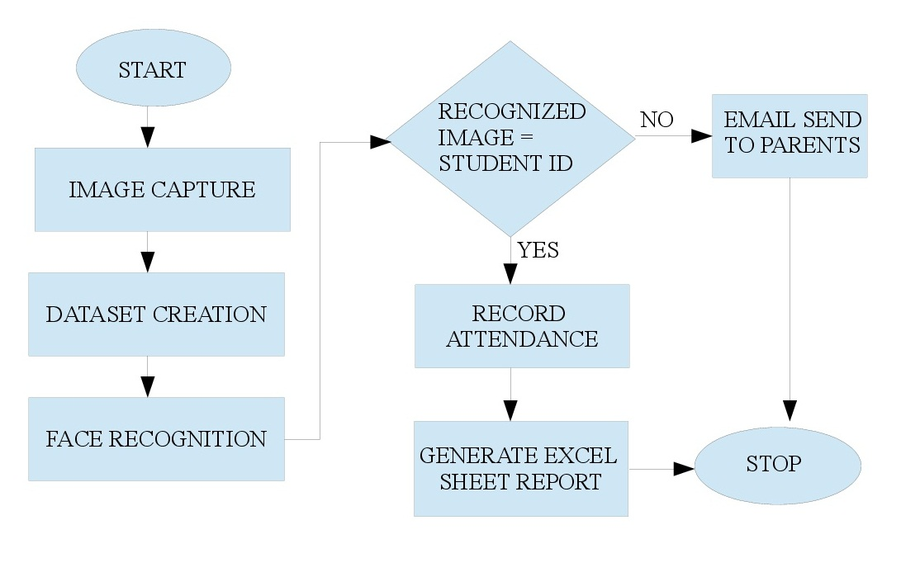
Fig: III.I Flow Chart

III.I Database Creation – Database of student is created before the recognition process, which includes one image of each individual. This is done by the respected teacher through the admin panel. During this process admin will simultaneously enter the student’s name and their parent’s email id. After taking images using a camera, an excel sheet will be created giving the database of all the students.
III.II Face Recognition – This is the most important part of the proposed system. As students enter the class, teacher will switch on the camera and it will continuously detect and recognize the face. After recognizing all the students present in the class an excel file is created giving the attendance of the class with date.
III.IV Sending Email – As the attendance sheet is ready, within one minute email will be send to the absentee’s employer or parent declaring that their employee or child is absent in today’s job assignment or class.
IV. HARDWARE SETUP
Hardware components used in the system are:
IV.I RaspberryPi-3 - The Raspberry Pi is a low cost, credit-card sized computer that plugs into a computer monitor or TV, and uses a standard keyboard and mouse. It is capable of doing everything you’d expect a desktop computer to do. The Raspberry Pi has the ability to interact with the outside world, and has been used in a wide array of digital maker projects.
IV.II Webcam - A webcam is a video camera that feeds or streams its image in real time to or through a computer to a computer network. When "captured" by the computer, the video stream may be saved, viewed or sent on to other networks via systems such as the internet, and emailed as an attachment.
IV.III Display Unit – A two-dimensional display devices such as computer monitors and an actual amount of screen space that is available to display a picture, video or working space.
Fig IV.I shows the block diagram of the hardware used in the model. Main component is Raspberry pi, brain of the system. Power is provided using external batteries. Processing, data creation and result generation are the steps carried out by this credit sized computer. A webcam is used to take pictures during database creation and recognition process. SD card is connected as external storage, needed for storing data. Using Ethernet cable, pi is connected to display unit.
Fig IV.II shows the setup and components required for the proposed model.
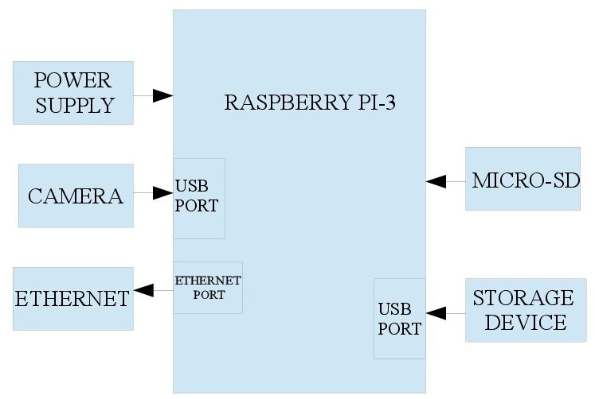
Fig: IV.I Block Diagram
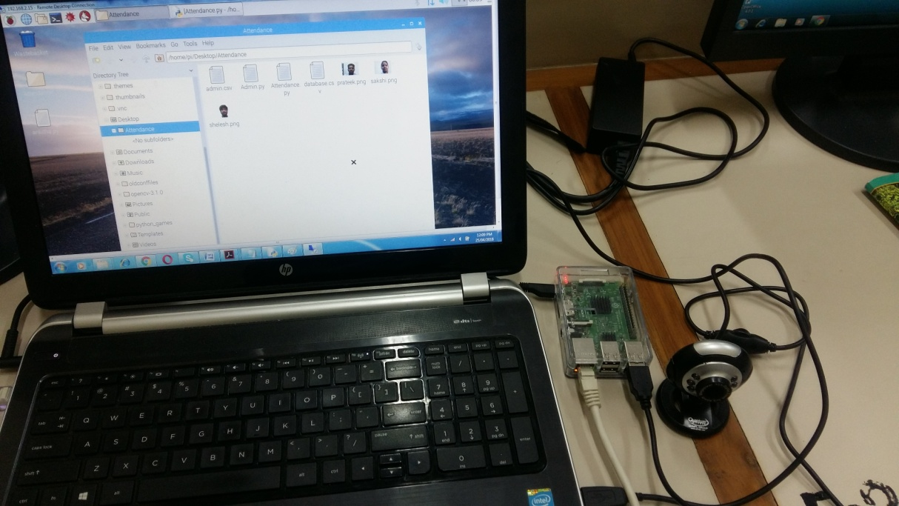
Fig: IV.II Hardware Schematic
V. RESULT
Results obtained by the model are shown in the following figures.
Fig V.I: Database creation of the students enrolled in the class. Webcam takes only one image of each student and stores for further process.
Fig V.II: During database creation, student’s name and parent’s email id is entered.
Fig V.III: An excel sheet of database record is generated including every student’s name, image and corresponding parent’s email id.
Fig V.IV: Recognition is done for attendance marking.
Fig V.V: An excel sheet of attendance record is generated.
Fig V.VI: E-mail is send to absentee parent mail using concern faculty id, informing the attendance of their child in the particular class.

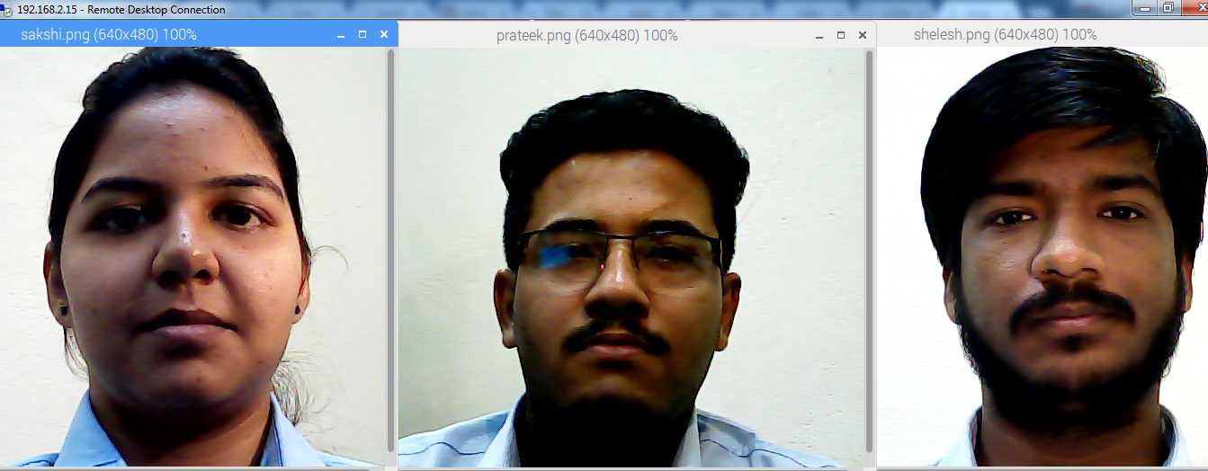

Fig: V.I Database Creation

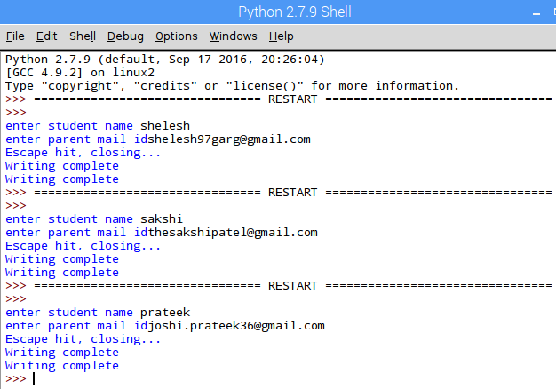
Fig: V.II Database created with parent email
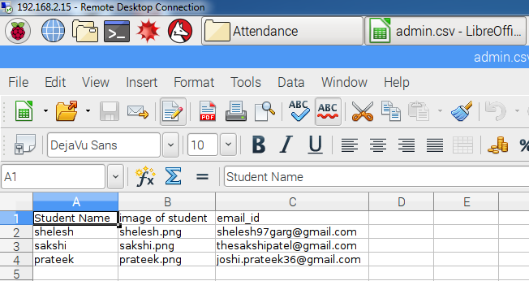
Fig: V.III Excel of database created

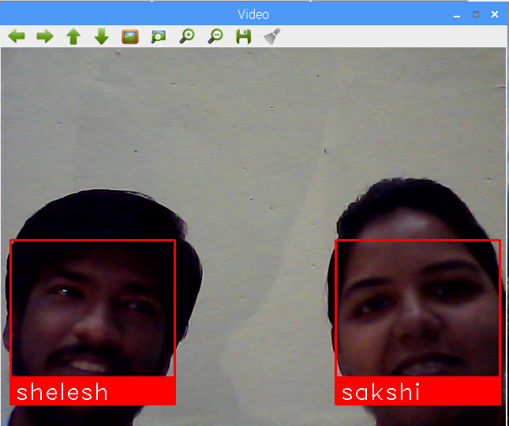
Fig: V.IV Recognition

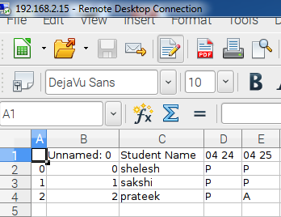
Fig: V.V Attendance record generated

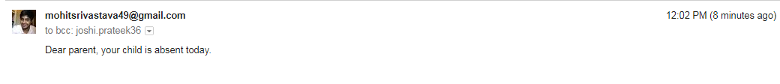
Fig: V.VI E-mail sent to absentee’s parent

VI. CONCLUSION
As we all know that face is an important identity of each and every person, with the concept of face recognition our project describes the importance of automation in the running era. This project consists of modules of OpenCV algorithms on python platform. This project also allows others to look forward for more improvisation with new innovation for upcoming changes in hardware & technology. The model has an accuracy of 99.38% and provides a simple face_recognition command line tool which is far more better than the general algorithms as it needs only one image to work on and not necessary to convert it in gray scale. Haar cascade, LBPH, eigen face all these need thousands of samples to calculate distance between points and pixels of the image. To make use of IOT, email feature is used which is inbuilt in raspberry pi. SMT Protocol helps us to do so. The future scope of the project can be increasing speed and accuracy of the model.
ACKNOWLEDGMENT
Authors are highly indebted to JAYPEE UNIVERSITY OF ENGINEERING & TECHNOLOGY GUNA, (MP) for providing the required platform as well as resources without which completion of the project would not have been. Our deepest thanks to our guide Dr. Ravi Kumar for taking part in useful decision & giving necessary advices, guidance and arranged all facilities to make life easier. We choose this moment to acknowledge his contribution gratefully.
REFERENCES
- Charles A. Walton, electronic identification & recognition system Filed: Dec. 27, 1971 Appl. No.: 212,281.
- Michael Dobson, Douglas Ahlers, Bernie DiDario, “Attendance Tracking System", United States Patent Application Publication, Pub. No.: US 2006/0035205 A1, Feb.16, 2006.
- O. Shoewu and O.A. Idowu, “Development of Attendance Management System using Biometrics ", The Pacific Journal of Science and Technology, Vol. 13, Number1, pp.300-307, May 2012 (Spring).
- L. Sirovich and M. Kirby (1987). "Low-dimensional procedure for the characterization of human faces". Journal of the Optical Society of America A 4: 519–524.
- M.Turk and A. Pentland, "Eigenfaces for Recognition", Journal of Cognitive Neuroscience, March 1991.
- Viola, P., & Jones, M. (2001). Rapid object detection using a boosted cascade of simple features. In Computer Vision and Pattern Recognition, 2001. CVPR 2001. Proceedings of the 2001 IEEE Computer Society Conference on (Vol. 1, pp. I-511).
- C. Papageorgiou, M. Oren, and T. Poggio. A general framework for object detection. In International Conference on Computer Vision, 1998.
- Automated attendance management system based on face recognition algorithms Computational Intelligence and Computing Research (ICCIC), 2013 IEEE International Conference.
- Robust 3D Face Recognition. International Journal of Computer Sciences and Engineering (IJCSE), 2015 Volume-3, Issue-5 E-ISSN: 2347-2693
- Monitoring Driver Distraction in Real Time using Computer Vision System. International Journal of Computer Sciences and Engineering (IJCSE),2017Volume-5, Issue-6, E-ISSN: 2347-2693

AUTHORS PROFILE

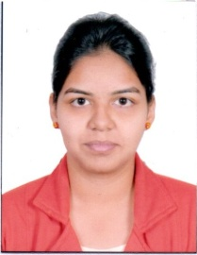
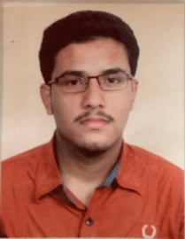
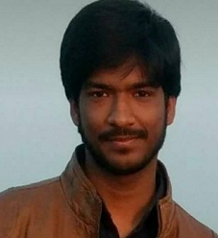
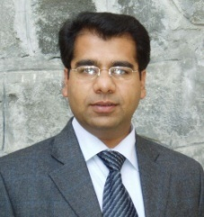
Sakshi Patel is currently pursing B.Tech degree from Jaypee University of Engineering and Technology, Madhya Pradesh, India. Her subjects of interests are Wireless Communication and Image Processing.

Prateek Kumar is currently pursing B.Tech degree from Jaypee University of Engineering and Technology, Madhya Pradesh, India. His subjects of interests are Wireless Communication and C++ Programming.

Shelesh Garg is currently pursing B.Tech degree from Jaypee University of Engineering and Technology, Madhya Pradesh, India. His subjects of interests are Embedded and Image Processing.

Ravi Kumar working as Assistant Professor(SG) in Department of Electronics and Communication Engineering, Jaypee University of Engineering & Technology, Guna with the specialization in MIMO Communication Systems and Smart Antennas. He has a good research exposure and published several research papers in the various journals of repute.

